458th Transportation Company (PBR)

Reflections of Thomas J. Wonsiewicz

November 2003
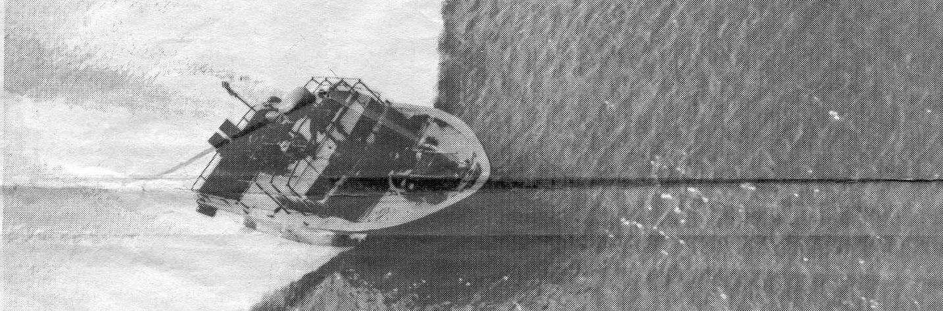

The Reason to Write
The following is an attempt to record my recollections before they are lost. I served with the 458th from May 1969 to May 1970. I can’t vouch for how accurate my memory may be after all these years, and I’m sure it is not very complete. Possibly this will serve as an ember to spark others who marked there service with a stint in the 458th Transportation Company—Patrol Boat River (PBR). And, just maybe, it will provide some depth perception to those who want to gain an understanding of what it was like to serve, in this way, at that time and in that place called Viet Nam.

I write this as our nation finds itself at war in Iraq. While the 9-11-01 attack on the World Trade Centers evoked a patriotic response not seen since WWII, that was two years ago. We are at a point where, to accomplish the mission, continued perseverance is needed—but patience is wearing thin. The growing sentiment is to get our troops out of harms way—to get them safely home. Sounds familiar, doesn’t it.

I have corresponded with a few young warriors who are in this fight. It has made me realize how we share a common a bond even though we are separated by three decades of living. I have come to realize there is a bond that connects warriors in the cause of good throughout the ages. The time, place and circumstances may change but the core experience does not. Fear, loneliness, camaraderie, the desire to do a good job and the toll extracted by living in harms way are the common bond of all soldiers of all times.

Returning home from a recent business trip I encountered a PFC and buck Sergeant in the Philadelphia airport dressed in desert fatigues. (Only moments earlier, I was reminiscing of that early morning wait in the Spring of 1970 for the plane to return me home to my family.) They were traveling on the front end of a 2 week R&R. I shook their hand, thanked them for their service and told them to stay safe. I wish I could have imparted what I feel for them in my heart. Words come up short. Recently I attended a welcome home for the son of a friend. He is a Cobra pilot in the Marines and was part of the Expeditionary Force to receive the Presidential Unit citation for their work in Iraq. His dad drove Hueys in Nam. It was a joyous time. Nonetheless, I noticed that the young pilot had “the look”. Thirty-three years after my hitch in Viet Nam was up, I am finally learning to recognize and understand a little more about what lies behind that look.

Here’s to all you who understand what I mean: I appreciate your service and the sacrifice you have made in the cause of freedom.

Getting There
I’m from Allentown, PA, the son of a first generation Polish—American baker. I graduated from the University of Scranton in 1967 with a degree in Accounting. Army ROTC was required. I was too short-sighted to see what lay ahead so I dropped it after two years. It didn’t take long after graduation to feel the heat of the draft on the back of my neck. I had learned enough to read a military pay scale. Newly engaged, I knew it would be tough to support a wife if I were drafted. The Army was offering college grads a deal. If you made it through OCS they would commission you in the branch of your choice, and you’d have a two year hitch after commissioning. It all worked out to just under three years, so I signed up. When the recruiter asked for my interest, I knew the difference between the Combat and Non-combat arms and requested the Quartermaster Corps. It wasn’t available; he suggested Infantry. We settled on the Transportation Corps—it sounded like the safest to me.

I entered basic training in the fall at Fort Dix, NJ and stayed on for Infantry AIT. It gradually sunk in during that cold winter that Uncle Sam had raised the ante. If I washed out of OCS, I’d be carrying the MOS of a rifleman—a grunt. I found focus.

AIT was completed in mid-December of 1967 and I married Lois, my high school sweetheart, just before Christmas. She was 22 and I was 21. We were kids, but didn’t know it. After a winter honeymoon, I reported to Ft. Belvoir, VA to enroll in the Corps of Engineers OCS Class 508 Alpha.

What happened to Transportation? Well, they closed that OCS while I was in Dix, but were still bound to hold up their end of the deal “…a commission in the branch of your choice.” It was the darndest thing. My entire OCS Class was composed of college grads in the same boat as me. Half of us had signed up for Transportation and the other half for Ordnance. We were oddballs from the get-go. Nonetheless, we learned to construct buildings, roads and bridges and how to blow them up. OCS was tough, but it was a pivotal experience in my life. About half way through the six month program our MOS was changed from grunt to “Blaster” (demolitions)—the motivation to graduate was still there.

In the spring of 1968 I received my gold bar and the “flying manhole cover” of the Transportation Corps. I also received orders to report to Ft. Eustis, VA to attend the basic officer course—after all, I knew nothing about the branch I had just been commissioned into. That lasted two months and was very boring. After basic, AIT and OCS I was trained out.

I tried to transfer to the Quartermaster Corps, pointing out how I had extensive experience working in my father’s bakery. No one was impressed. I soon felt that heat on the back of my neck again. Attempting to put off the inevitable, I signed up for the longest school I could find that didn’t involve helicopters: Harbor Deck Officer’s Course. It lasted six months and was taught mainly by ex-Navy Chiefs who switched branches and became warrant officers. Seamanship, navigation, boat handling, stevedoring, tug boats, landing craft, port operations—we were taught it all. It was fascinating and enjoyable. Then back to reality.

After a few months as the junior second LT in a holding company in Eustis, I received my orders for Viet Nam. I was 23 years old.

The Inevitable
It was hard to leave my wife. I had never felt such a knot in my gut as when I turned my back to her and walked to the plane at the Patrick Henry Airport in Newport News, VA. I didn’t feel like a patriot going off to serve his country. I felt scared.

What little we owned was crated and put in storage. Lois completed the school year and moved back to Allentown to wait it out with her folks. She was worried too, but kept a brave face. I remember the letter she had stuffed into my duffle bag. In my attempt to calm her concerns I explained that Transportation was a “non-combat” arm and that everything would be OK. I said the worst thing would be if I were assigned to a river boat unit I had heard about, but that was unlikely since I hadn’t been trained for it. Right.

Across the Pond
Going to war in a 707 and being served a steak dinner enroute—is that bizarre or what? I fully expected to get my ass shot off the moment we passed over the VN coastline. Arriving at the replacement depot in Long Bihn took the starch out quickly. Man, was it ever hot! The processing seemed a blur until my orders were cut. I was assigned to the 458th Transportation Co. (PBR), attached to the 92nd MP Battalion. I would be picked up the next morning. No one seemed to know anything about the 458th. What kind of Unit is it? Why are they attached to an MP Battalion? What’s a PBR? Then I found out. The knot in my stomach returned—big time. I remember the guy who explained things also said there was some good news. The CO HQ was in a place called Vung Tau—a real garden spot on the coast.

I could hardly sleep my last night in Long Bihn. Beside the climate and the never ending sounds of camp life, I felt very alone. I vividly recall lying on the cot realizing I am half way around the world from everything that is dear to me. I remember being terrified by the reputation surrounding the word “PRB” and anxious that I would be able to cut the mustard.

The next morning my ride showed up. We went to Saigon, not Vung Tau. The HQ had been moved and was now located in a compound near Ton Sun Nhut airport.

Reporting for Duty
Second Lieutenant Wonsiewicz reporting for duty, Sir! At ease, relax, take a load off—welcome to the 458th, said Capt. Eugene Schumbris, commanding officer. His face looked familiar to me, then I made the connection—he used to be in charge of the PX at Ft. Eustis. I had bought a stereo set from him. For a Captain he had a boyish face.

Unit Clerk-Pershing Field
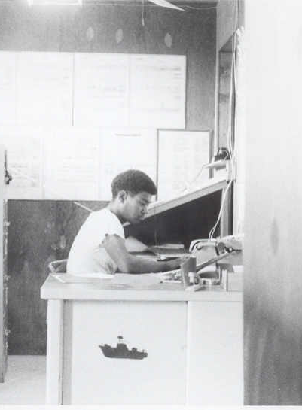
I was given the cliff notes description. The 458th existed to operate river boats essentially in the defensive role of port and harbor security. The unit provided a two man crew, coxswain and engineer. The MP’s a third and a VN National police man filled out the crew of four. The Unit was dispersed through out the country: Newport Docks, Cat Lai, Vung Tau, Vung Ro Bay and Qui Nhon. We were a bastard outfit—the only one like it in the Army.

The compound, which served as the MP battalion HQ was small. There was no room for me in the BOQ—they sent me to a hotel. That was weird, but didn’t last long. As the junior officer, I wound up with all the BS details. And I was assigned to be the Supply Officer. Like a fool, I signed off on the inventory even though there was no possible way for me verify what was or wasn’t on hand in each of those outposts. I’d find that out later.

BOQ—“Home Sweet Home”
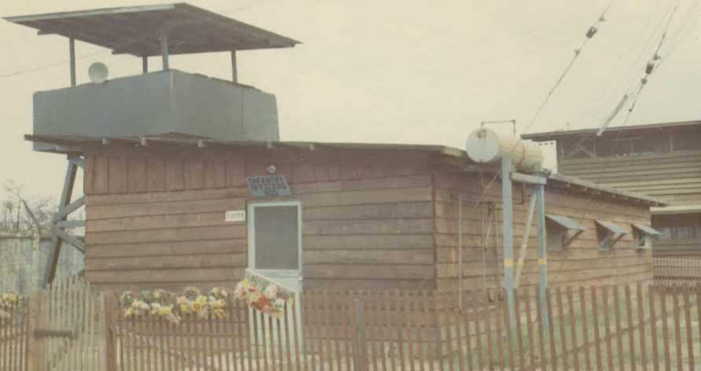
The first taste of regular duty was to mother hen the patrols running out of the Newport Docks. I had no experience with these boats and was anxious to get familiarized. The NCO’s and crews were tolerant of my interest. I recall cruising down river to inspect the patrol area. Once we were in open water, the demonstrations began. Full speed, fast turns and all that stuff. “Would the Lieutenant like to see an emergency stop from full speed ahead?” Sure, I responded. I was instructed to stand amidships and take a firm hold on the aft edge of the canopy. “Are you ready, Sir?”

Man, did I ever get it. As the nose of the PBR dug a hole in the river the bow wave completely drenched me. I felt like a fool, but the ice had been broken—my initiation was complete. Having that experience made it all the sweeter throughout my tour as we would do the same to various VIP’s who wanted an ego ride on a river boat.

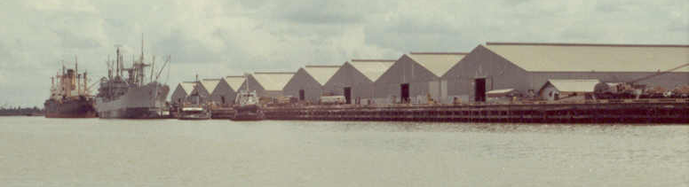
Newport Docks

I took the helm for a while to get a feel for how the boat handled. It was different from my training experience. As we approached the barge in Newport, the Sergeant offered to bring it in. Being cocky, I said I could do it. That’s when I learned that Jacuzzi jets don’t make very good rudders. We hit hard, but without any real damage. My humiliation was now complete and my respect for the guys who knew how to make those boats perform began to grow.
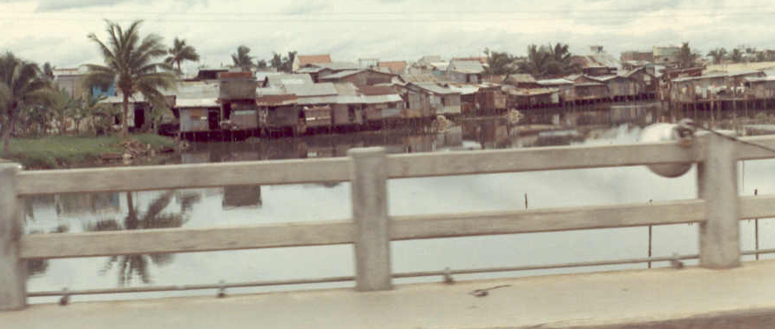

Gia Dihn Section
Of Saigon--
What a smell!

I recall nothing exceptional about that time. It was boringly routine. I can still smell the 2-cycle exhaust and sewer gas odor of that daily trip across Saigon, the confusion of the traffic, the sounds of the horns, cyclos and motor bikes.
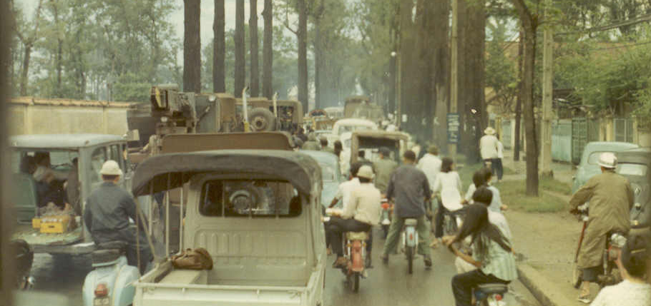

Tu Do Street
Rush Hour

Change
There was trouble in our unit, but I can no longer remember the specifics. I think our readiness was in the pits. Too many boats were on deadline status. The result was the assignment of a new CO, Capt. Blaze Mancini MP.(We later heard that Schumbris died in a helicopter crash. I have since found his name on the Wall in Washington.) Mancini was more hands-on. I liked him and his style. If I’m not mistaken, he joined the service as an enlisted man and went the OCS route to gain a commission. He was from Philadelphia which is only 60 miles from my hometown.

Captain Mancini--CO

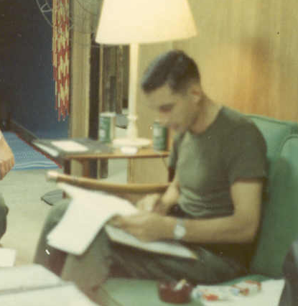
I was sent to Cat Lai where, at that time, we had the most boats in the water (6 or 8). From there we patrolled the harbor, and adjacent areas to include Nha Be and half way up river to Saigon. We had a barge at the dock with a communications shack and an ordnance/ammo connex. We also provided escort service for the ammo barges running up river to Long Bihn.
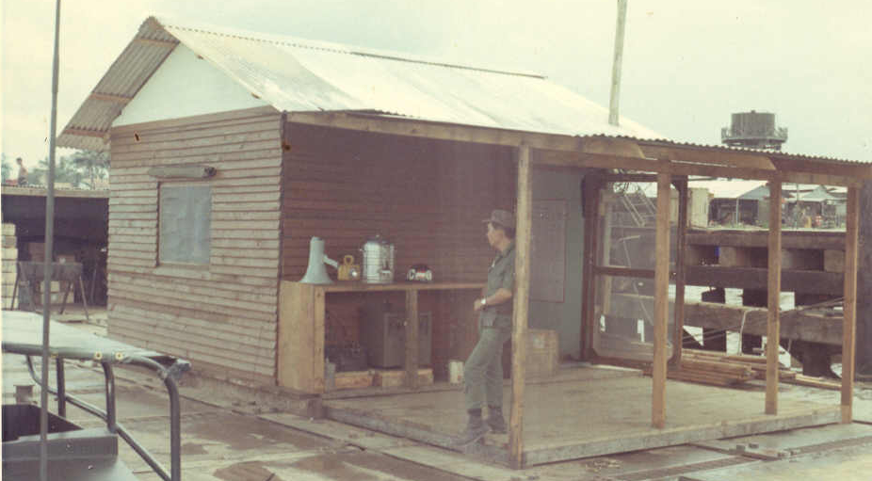

The troops were in a single, 2 story barracks which housed the 458th, the attached MP’s and some of the VN police. I shared a room in what had been a two story French villa. It was a compound within a compound; we had VN navy/marines on three sides.

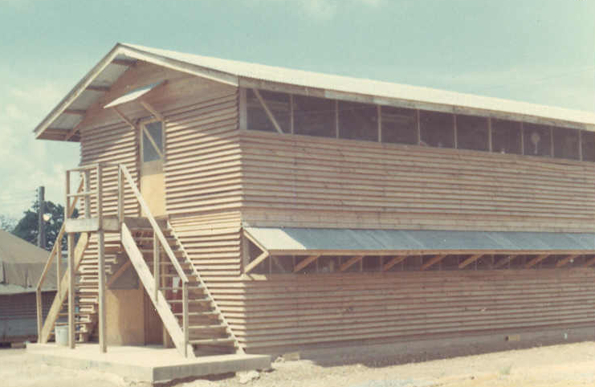
There was also a US artillery battery nearby. Most nights they had fire missions that sent rounds out over our heads. They had some kind of fancy radar gear that could detect people on the march. They claimed they could tell the difference between a man, woman or water buffalo. It all just looked like squiggly lines to me. I remember them being frustrated in getting clearance to fire.

There was risk at this place. The wide river usually had three ocean going ammo ships at anchor being unloaded onto barges. If one of them blew it would be devastating. The entire compound would be wiped clean off the face of the earth. Sappers were the challenge. We were on guard for charges either attached to hulls or to lines tied to the moorings which the current could carry next to the hull. Luckily, these were tidal rivers with swift currents, so the danger was mostly during slack tide. The ships hulls were lit at night; guards on board were to keep a sharp watch during the change of tides. And, there were the grenade runs.

Ammo Barges at Anchor

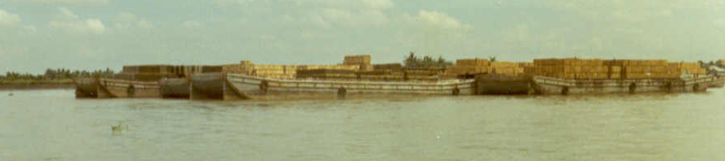

Base, Base, this is Charlie Papa 41 commencing run. Roger that Charlie Papa 41.

In the quite of the night you could hear the two GMC diesels come to full throat in the distance and the sounds of a PBR hull on plane. Then it began: whump… whump… whump as the crews rhythmically tossed the one pound concussion grenades overboard along side the anchored ships and barges. I wonder how many fish we killed in those exercises to keep the sappers at bay. I also wonder how many merchant seaman had their pucker factor raised until someone explained the purpose of those explosions.
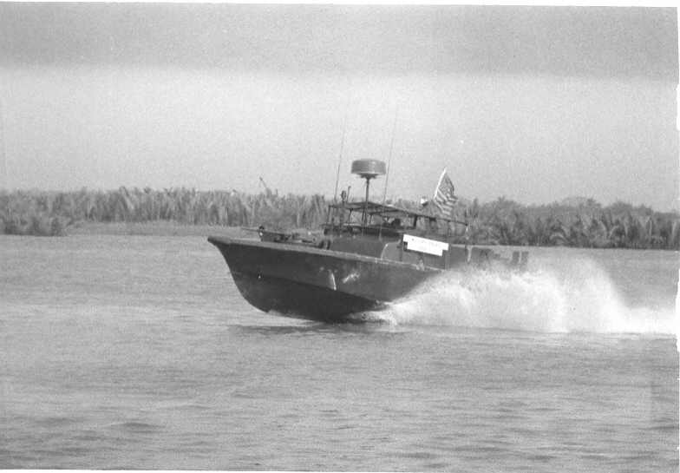

Full Bore

Young GI’s and concussion grenades are a dangerous mix. The temptation for play is irresistible. I recall listening one night to a run from the shore. The rhythmic whumps were punctuated by a flash and loud BANG. Apparently one grenade got tossed up in the air, instead of down into the water. I’m sure there was more play than I ever heard about, especially out in the back waters. Some of it, I know, was deadly dangerous. Having had demolitions training, I knew first hand what that stuff can do.

Exhibit A
The main focus was to keep sappers away from those ammo ships. One night, a small merchant freighter wasn’t so lucky. It was at anchor between Cat Lai and Nha Be. Its rudder and propeller were pretty much gone. It was a real rust bucket. While not our responsibility it stood as Exhibit A in testimony to the risk we lived. The theoretical was possible.
Sitting Low in the Stern
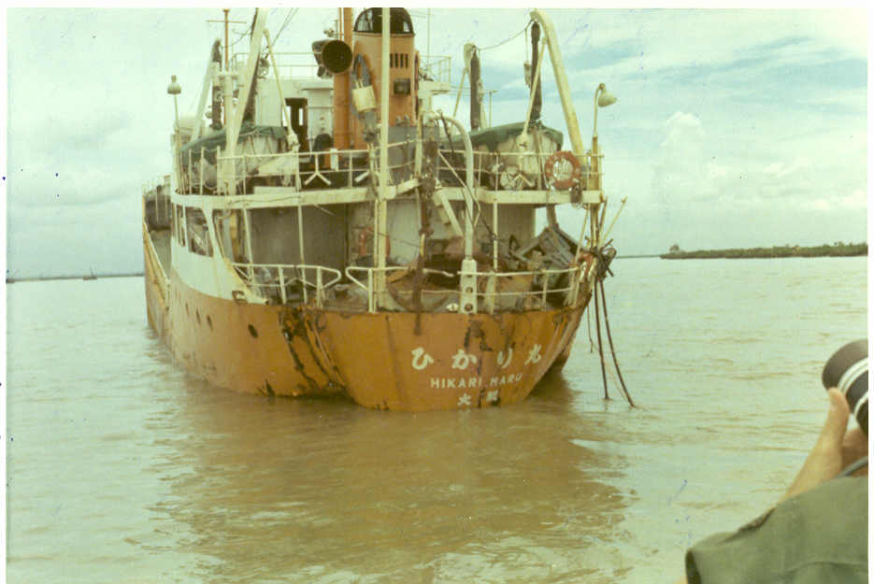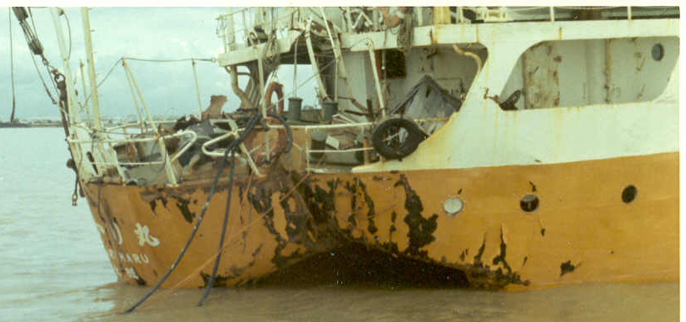

Frustration
Keep the sampans out of the harbor and away from the ships and barges.
That was our charge. It was easier said than done. It would be easier to keep high school boys away from high school girls.
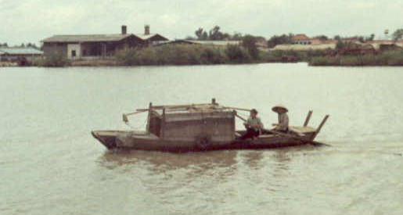

Ubiquitous Sampan

The lure for the locals was irresistible—dunnage, and lots of it. The ordnance cargos were securely packed in the holds with massive amounts of lumber to hold them in place. The VN stevedores, under the watchful eye of the Coast Guard, were “supposed to” off-load the dunnage onto a barge and keep it out of the river. Right. It was a heck of a lot easier just to toss it overboard. So the stage was set. A seemingly endless supply of Grade A lumber floating on the river was being chased and scooped up by a flotilla of sampans. Who could really blame them? There was enough scrap wood on each ship to build a village.

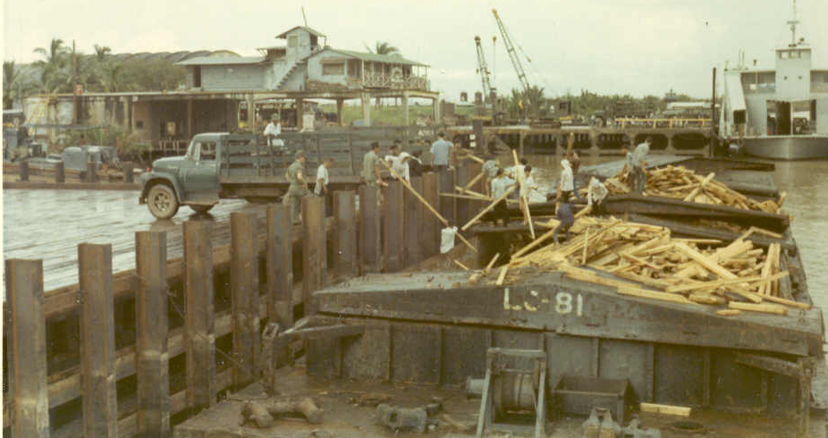
There would be crack downs. Our patrols would bring in the “looters” and the VN police would haul them off. It made little difference—they were back the next day. I recall one woman and small
child hauled in three times in two days. We made an effort to give away the wood in a controlled fashion. It was bedlam. The local politicians were lining their pockets.

Cat Lai Public Warf (Ferry—top rt.)

Snap!
Shortly after the small freighter was mined, we were cracking down hard on the sampan traffic. After hauling in the same person three times, one of the guys lost it.
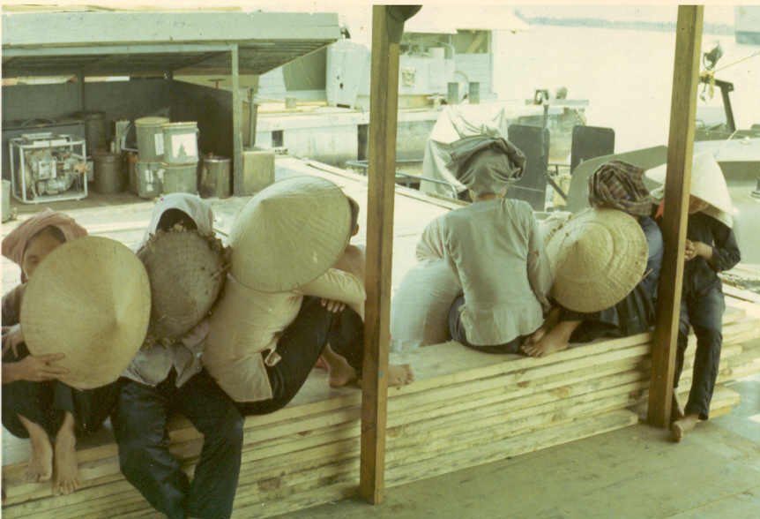
Perpetrators

With the locals safely aboard the PBR, he locked and loaded his M-16 and proceeded to turn the sampan into toothpicks. While certainly not authorized, I can still see what he did as the logical result of trying to do his job. That sampan wasn’t going to be a problem again. The toll of the 12 X 7 duty, in a sweltering climate with little chance to unwind just became too much to bear. What he did was wrong; but it was understandable.
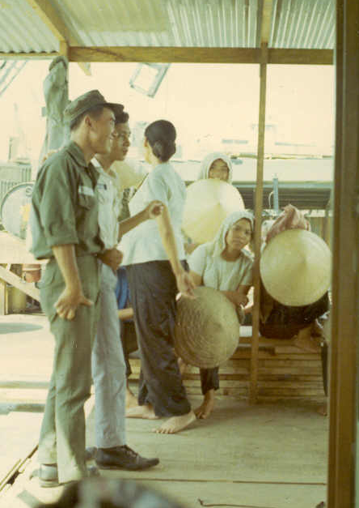

Awaiting
Arraignment?

The locals were turned over to the police, but the poop hit the fan. We were reprimanded and were to pay for the destroyed sampan. I don’t recall how that was accomplished.

That experience taught me how close, in a combat zone, we all are at the edge of what civilized people do.

Escort Service

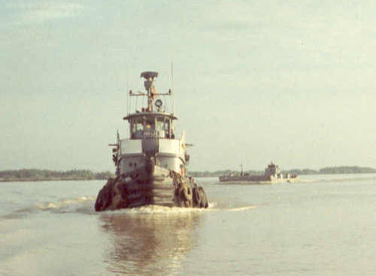
In addition to the harbor patrol, we also provided PBR’s as escort for the tug-barge convoys going further up river to the Ammo dump. That duty had an edge to it since you were pretty much a sitting duck—especially at low tide when the water level dropped many feet below the river bank.

During my stay, things were relatively quiet on this stretch of water. One crew was very worried about this duty, especially at low tide (the convoys were always during daylight). One day they showed up with a strange looking device mounted where the aft 50 cal. should be. It was a breech loading 60 mm mortar, which could be fired conventionally as a mortar or aimed like a cannon. They had “acquired” it from the Navy. I encouraged them to carefully read the instruction manual.
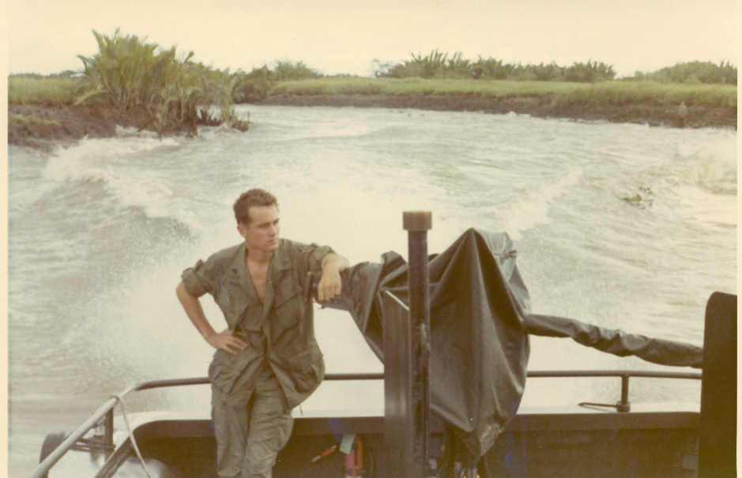

Running Home from Cogido

I recall one of our crewmen getting his hand shot up. I visited him in the Saigon hospital, Purple Heart pinned to the pillow. He was awaiting transfer to Japan to have reconstructive surgery.

Cogido
That was the place the boats tied up while waiting for the tugs to drop their loaded barges and pick up empties for the trip back to Cat Lai. There was a dock by a small village that was a favorite of the crews.
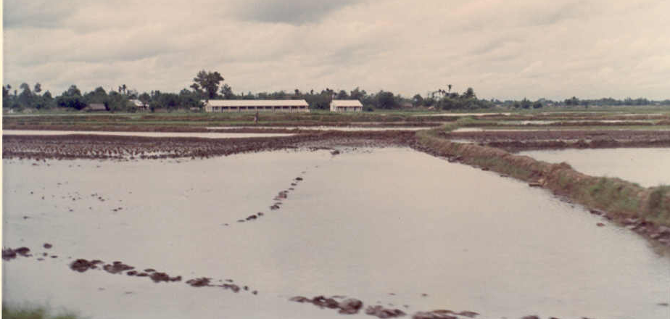
Flooded Rice Paddy
(school in distance)

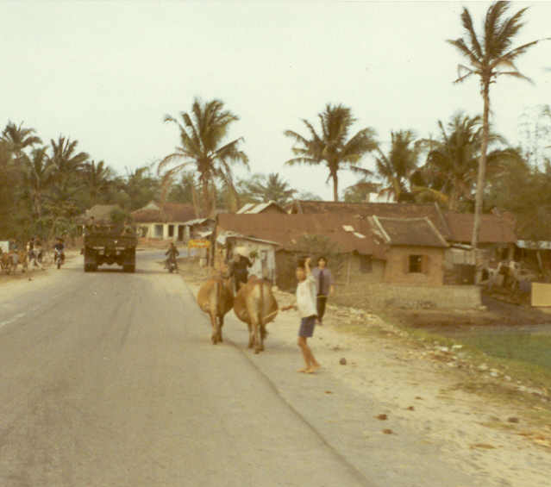
They would often go in for some local flavor—and they weren’t just shopping. One day, the roof fell in on us. HQ called me in the carpet, because they had been called on the carpet, etc., etc. It turns out that village wasn’t just a village—it was a model village populated by rehabilitated Viet Cong.
Apparently, one of our crew was consorting with a local and was “discovered” by the woman’s husband. After he was run off (lucky not to have been shot), a complaint was lodged. It climbed its way up to the US Ambassador’s office and then, picking up speed and force, down the MACV chain of command to yours truly. We promised to behave better in the future.

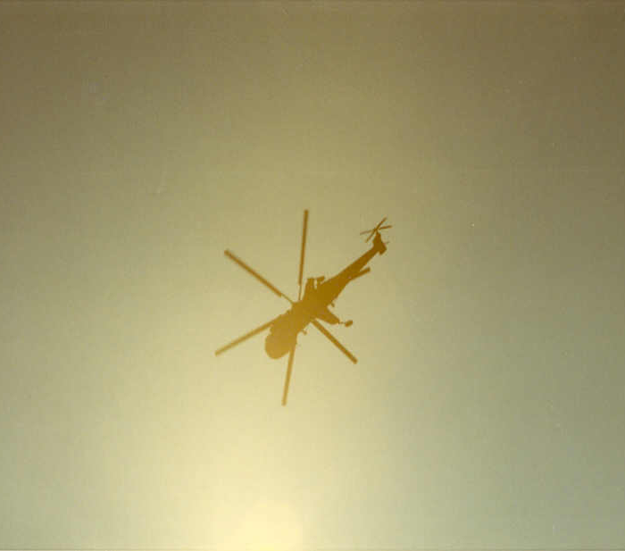
I also have a dim memory of a PBR out of service and beached in that area. The idea was to bring in a Sikorski Sky Crane to lift the PBR onto a Mike boat. The backwash from the copter flattened a number of hootches.

Mr. Gibbs
The tug boats were Army, operated by the Transportation Corps. Most of the crew was VN civilians.
I recall hearing a familiar growl on the radio from a tug wanting instruction on which buoy to tie his empty barges. I got on the horn and asked his name. “Mr. Gibbs” came the reply, “and who’s asking?” He had been one of the more colorful instructors at Eustis. When I identified myself, he said “Lieutenant, get your ass out here right now! I need a hand.” Did he ever!
One of the patrols dropped me off. Before I could say hello, he began issuing a string of orders. I was transformed into a deck hand. After a while the barges were tied off to the mooring, the job done. He broke out a cooler filled with San Miguel beer, on ice.
He explained that he had run out of patience with his VN crew. They were late to report that morning, so he left without them. He was the only person on board. The trouble was, he couldn’t skipper and stevedore at the same time. He was a good guy—a career soldier with a gravely voice. “Get yourself to Thailand, Lieutenant—those young brown bodies can work wonders” he would say.
Even now, when I drink a San Miguel I toast Mr. Gibbs and the day I was his deck hand. It makes me smile.

The Navy
The Navy base in Nha Be was a god send. Had it not been so close at hand, I doubt if we could have kept as many boats running. They were the only place we could get major engine or hull work accomplished. On a couple of occasions, I was able to eat in their mess hall (or whatever the Navy calls it). What a difference. The chow was great. By comparison, the Army seemed to love misery.
Nha Be also supported the Navy’s Swift Boat operations and some PBR’s too. Those crews were different. Most were bearded (the days of Admiral Zumwalt) and all were cocky. They used their floating assets to look for trouble and generally found it. I remember seeing one PBR up on the dock. An RPG had penetrated the hull between the forward gun tub and the coxswain’s station. You could easily see daylight through the gaping hole.
One guy told me their unit averaged 1.1 Purple Hearts per man. I don’t know if that was true or not, but it made my skin crawl. The thing I most appreciated was their floating crane.

Excessive Water in the Bilge
“Come quick, there’s a boat sinking at the dock!”
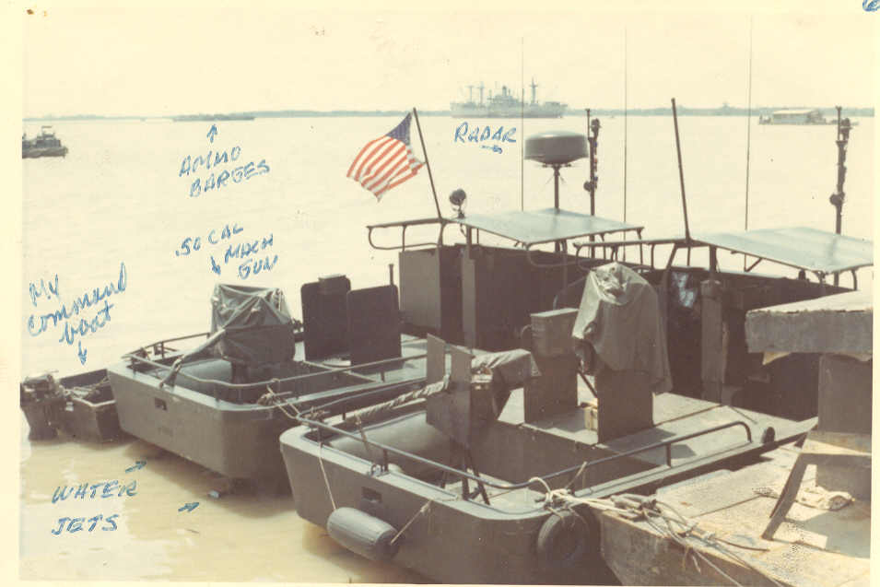
Cat Lai PBR’s

(view across river;
ammo ships and
barges in background)

We shot out of the mess hall leaving our lunch unfinished and ran down to the barge/CP. Where there had been five boats there were now four. The outboard boat in a line of three had gone down. The quick action of the radio operator saved the other two in the row from being dragged down with the sunken boat.

What the hell had happened? No one knew.

On the horizon, ready to make the turn to Nha Be was a large floating crane. It had traversed the harbor an hour or so before. Luckily, we were able to get it to come about and lend a hand.
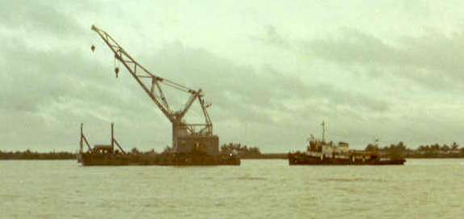
When the tide slackened the crane lowered the lifting beam and divers, working by feel, made the connection. Slowly the boat was brought to the surface; a Mike boat stood ready to take it to Nha Be for restoration. As it was lifted higher, inch by inch, there was no obvious indication of why it sank. Then, the stern transom cleared the water. Two large streams of water poured from the inspection ports above the water jets. I looked at the E-6 maintenance sergeant. The color drained from his face as fast as the water was draining from the boat.
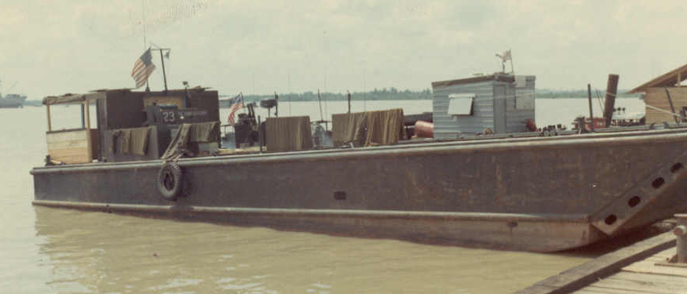
LCM-8 “Mike Boat”
(1099th Trans Co.)

He had been pulling a maintenance check on the Jacuzzi gate controls and got distracted. When the call for lunch came, he departed, leaving the two inspection ports uncovered. The boat traffic in the harbor caused water to slosh up into the open ports. Little by little, the freeboard decreased. At some point, the open port became a siphon and down she went—right at the dock. How embarrassing.
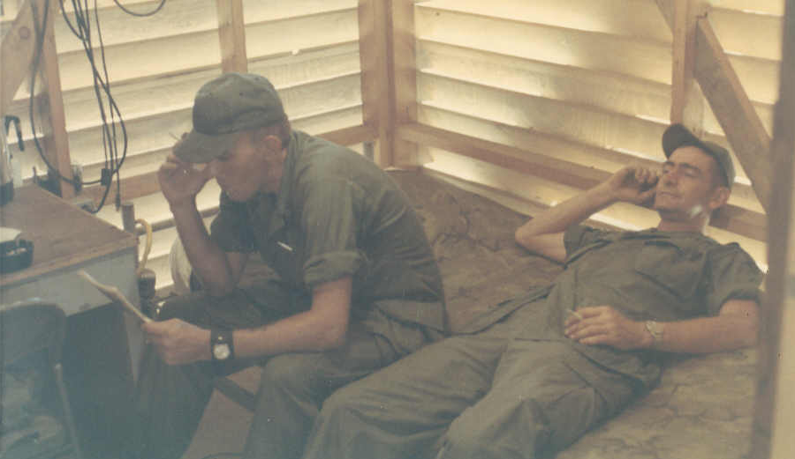
Sergeants Edwards (rt.) and Callaway (left)

So who forgot the inspection caps?

Later that day, battalion HQ made their daily check on readiness. They were hell on anything dead lined. “What should I tell them, Lieutenant?” the radio operator asked. “Report hull number J-7815 (or whatever it was) as deadlined”, I responded. He did.
A little later HQ was back on the line. They wanted to know what the problem was. “Tell them there is excessive water in the bilge”. He did as I asked.
A very short time later, the radio crackled again, “How much water is in the bilge?” they asked. “Twenty feet”, was our reply.
The next call was pretty much instantaneous. I was ordered to report to HQ (Saigon) ASAP. By now it was dusk, and jeep travel not wise. I hopped rides to Newport on patrol boats and then hopped a jeep the rest of the way.
The BN XO (a red neck MP LTC) wasn’t amused with my attempt to deflect attention. I got a good butt chewing and basically lost a night’s sleep so I could be stood at attention for his tongue lashing. I later had my fun with him.
Accidents are accidents and this one was investigated like all the others. In the meantime, I was still Supply Officer. You know, it’s amazing how much stuff can be “washed away” in a strong current—if you get my drift. After requisitioning the “missing gear”, I was a little less short than before the sinking.

Cat Lai Camp Life
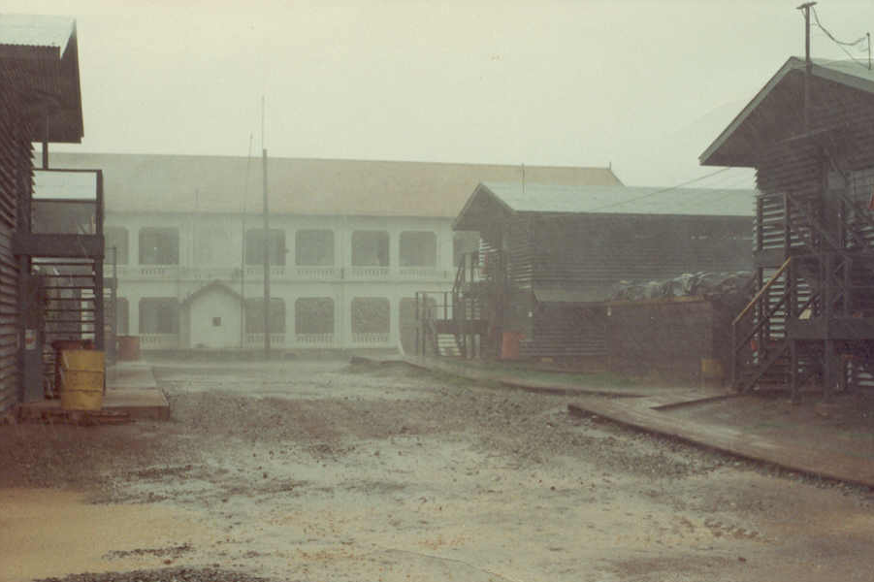
Moonsoon on the main drag

HQ/BOQ in background

Life in Cat Lai was a grind. Aside from our detachment, there was a small group of Coast Guardsmen, the artillery guys and some others. It just didn’t feel cohesive—everyone had their own little patch. At night, the routine usually involved a lot of drinking and sometimes card playing.
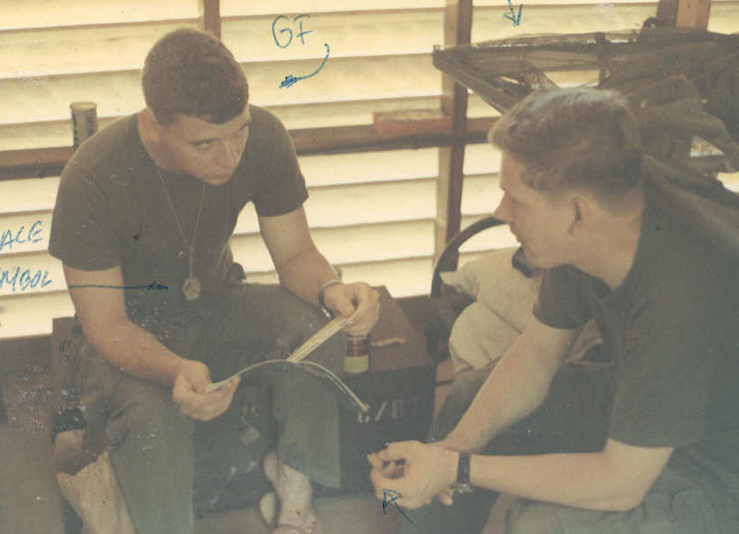
Cat Lai Radio Operators
(names are gone)

I can remember the crews complaining that the morning chow was a problem. I got up early a couple days for the morning crew change. The food wasn’t bad—it’s just that there was hardly anything to eat! The mess Sgt. wasn’t getting his crew going early enough. I hit the roof and chewed a new hole in his behind. Later, I heard about it from the base commander. “You are guest in our compound and should follow the chain of command”, I was lectured. While I watched my tone I made it clear that the duty sucked and the least we can do it put decent chow in front of the men. We may be guests, but our main job was to keep their whole compound from being blown to kingdom come. The service improved.
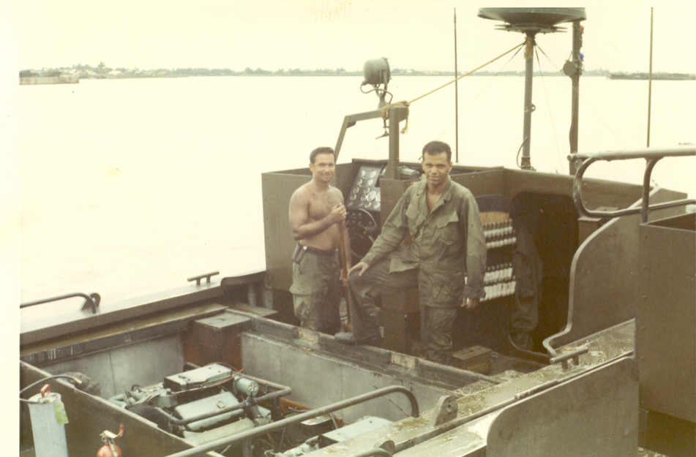
Two, very hard working GI’s

(40 mm grenade ammo racked behind guy on right)

Even so, we were out of the range of USO shows or anything like that. There wasn’t much in the way of recreation, and that wasn’t healthy.

Refer Barge Under Attack!
Well, not really. From time to time we’d take the crews out for some firing exercises. We’d get clearance from the Navy to shoot up the mud flats down river from Nha Be. We’d set a big smoke pot on the shore, back off and try to hit it. It wasn’t very easy, especially at full throttle. (That’s when my hearing started to go. Standing amidship, behind the coxswain, with all three 50’s and the M-60 blazing away broadside was painfully noisy.)
One time, we combined live fire practice with an escort run. A tug was pulling a refer barge (floating freezer) from Vung Tau to Newport. The barge had a crew of two, and they were new in Country. This was their first time on the river. Their mission was to keep the frozen food frozen. They had quarters right on the barge.
The PBR’s got together and concocted a ruse: the practice firing would be made out to be real action—an initiation to the new guys. They were warned to take cover below in their barge, and the firing runs began—along with some overly dramatic radio chatter. When the smoke cleared all was well—and the barge guys grateful they were still in one piece.
When we got them to Newport, off came a couple cases each of frozen steaks and lobster tails. We tapped the Unit Fund for charcoal and “33” beer. It was one hell of a cookout. I’ll never forget those charcoal grills made from 55 gal. drums, covered with the steaks and lobster tails. The guys deserved it. We all ate our fill and got loaded.

What’s an Escondido?
“Hey Lieutenant, I’m heading home in a couple of days. Have an Escondido with me.” The fellow skippered one of the boats and was a regular on the Cogido run. He was pretty well smashed. I accepted his offer and drank the Escondido. He said it was a drink from back home in California. It wiped me out completely. Funny the little things you remember.

The Red Cross
There was a young Spec 4 from Missouri who was our armorer. He was good—kept everything in firing order and plenty of ammo on hand. Working out of a connex container on the barge, he was good natured and cheerful—until the letter came.
I noticed his long face and asked what the matter was. He handed me a letter from home. It was from his wife. Though poorly written its message was clear: she was running off with another guy and taking the soldier’s baby with her. She also warned against pursuing them or she would kill him. The syntax was unclear as to whether she would kill the pursuer or the baby. His world had come to an end. That letter turned his good nature into complete dejection.
We got the Red Cross involved and he was sent home on a compassionate leave. Though no one got “killed”, he lost his wife and was not the same after that.
I recall how, at age 23, I felt totally inadequate to help this guy with his problem. It was just another personalized introduction to the cruelty of life and the cruelty of war.

Emergency Procedure
It was said that if you were taking on water faster than the bilge pumps could cope, pull the inspection caps from the top of the Jacuzzi’s and they would “siphon” the excess water from the bilge and prevent sinking. Somehow, theory sounds less complicated than reality.
Late one afternoon we were running up river, returning to Cat Lai. Gradually, our speed dropped and the hull came off plane—even though the engine RPM’s had not decreased. Oh—oh! When the hatches were raised there was a lot of water in the engine compartment, and it was rising pretty quickly. There was what seemed like an eternity of trying to figure out where the water was coming from. Finally, someone pulled the caps off the water jets before they were submerged.
What I didn’t know is that the first thing to happen is some sort of equalization. Water gushed in through the open jet caps and our freeboard decreased rapidly. It was a sinking feeling—literally. Then, balance was achieved. We were stable, but sitting low in the water and not making much headway at all. We had called in the mysterious trouble, but concluded that making it all the way back seemed a long shot. We headed for the shore and ran it aground about 25 yards from the bank on the Song Saigon. The sun was setting. Worse, the tide was running out at full tilt. We were stuck in place until the tide turned and released the mud’s grip.
It turned out that the river water return hose from the heat exchanger had let go. It was an easy fix. Nonetheless, it made for a long night.

Fire in the Night
You come to appreciate your vulnerability as you sit stranded on the water closer to the shore line than you’d like to be. While no harm came our way that night there was trouble in the neighborhood.
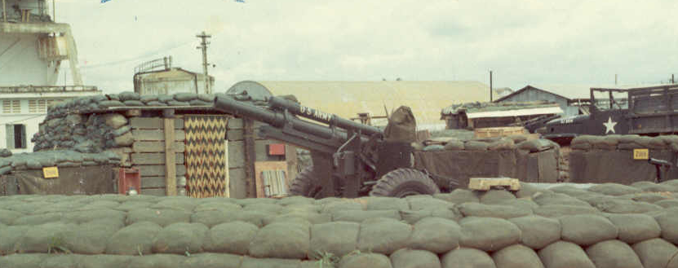
105mm Howitzer Battery

I can still here the sound of artillery cracking its way through the humid night air and impacting with a “crump”. I pictured our neighbors back at the artillery battery interpreting the squiggles on their radar screen and bring in the rounds. Later, the barrage became more visible as a cobra and “Puff the Magic Dragon” gunship came into play. This was all taking place several kilometers away so sound followed sight. The fire streaked from the gattling guns like a tongue of devastation. The sound was otherworldly; the impact a muted roar. I wondered how anyone could survive such awesome force, or if they did, whether it changed their will to fight another day. With the new day came the new tide. We were anxious to leave and didn’t mind going overboard to speed the process of re-floating the boat.

Next Time, Shoot Back
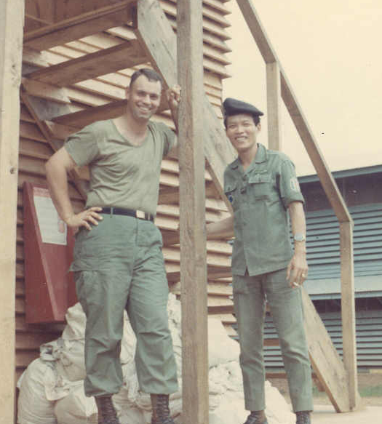
Two LT’s
One local…One not.
(T J Wonsiewicz on left)

The VN police assigned to our unit had bunk space in our barracks but pretty much came and went as they pleased. One, an outgoing skinny guy, was the man in charge. He wore a large, gaudy wrist watch that was way too big for his slender wrist. One day gun shots rang out. Their origin seemed to be at the gate manned by the VN Navy troops. The commotion dissipated but I was later called to the post commander’s office. The report he received said the shots had been fired by a VN Navy guard at one of the VN Police attached to our unit. I checked it out—no one knew (or admitted) anything. We all noticed that the skinny guy was not to be found for the next couple of weeks.
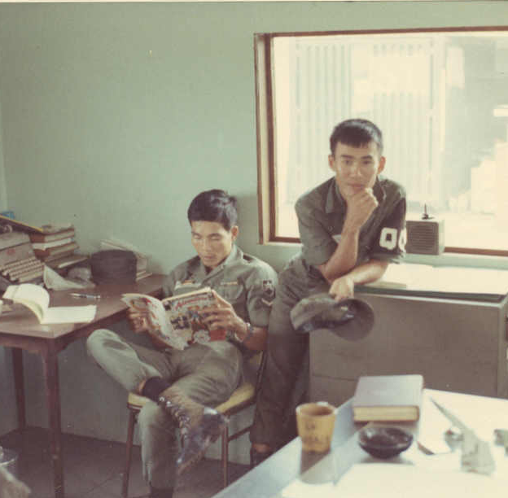
Vietnamese QC’s (MP’s)
Waiting for Shift Change

When he returned, his head had been shaved—a sign of public humiliation. He explained that there had always been some tension between the VN Police and Navy troops. The Navy envied the “privileges” that came from the close link to our operations (food, gear, easier duty, etc.) The day in question, the policeman was coming to work on his motorbike as he had a hundred times before. This time, the Navy guard motioned for him to stop and show his ID—a high insult. The request was ignored. After passing the check point, the Navy guy locked and loaded his M-16 and let her rip—hitting nothing.
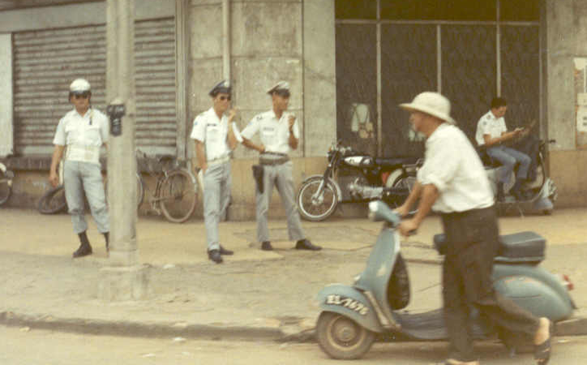
Local Police (dinky dau & corrupt)

When the cop got free of the scene, he reported the incident to his superiors. They reprimanded him for not carrying his weapon with him and shooting the Navy guard on the spot. The shaved head and two weeks in the can were his punishment for losing face.

Purloined Boots
There was some advantage being attached to the MP’s. With the unit markings on your bumper, traffic issues were not a problem. You could pretty much go where ever you wanted. When watchful eyes saw the “92nd MP” marking, they just waived you through—or didn’t issue the speeding ticket. We received the respect (fear?) afforded the MP’s without actually being one.
Well, most of the time. One day some guys from the Coast Guard detachment stopped by. They were all upset because their boots had been stolen. Their Mama-san had cleaned off the mud and set them out in the sun to dry. When she went to retrieve them, they were gone. There was a witness who saw them being carried onto the VN base.
“Come on Lieutenant, you’ve got to help us out—after all you are an MP Unit”, came the plea from the senior NCO old enough to be my father. We did some checking and got the OK to call on the VN base commander. By the time we showed up, they had found the perpetrators—a couple of new recruits. The boots were returned on the spot along with effusive apologies. All the while the recruits were in the “forward leaning rest position” straddling mud puddles.
I suspect they were being punished for getting caught rather than for the deed itself.

Did You Say Coast Guard?
Correct. The coaster—roasters had overall responsibility for the safe unloading. They were a small unit with their own hootch, led by a Lieutenant (jg)—a Coast Guard Academy grad. I envied him. Once a month he filed a written report to his superiors. That was it. We, on the other hand, seemed to be constantly under someone’s microscope.

Chicken Man
I no longer remember the Unit our battalion reported to, but I do recall the chicken man. He was a full bird colonel who was constantly out and about in his LOCH (small observation helicopter.) Whenever he got near a PBR, there was sure to be some gig for a fire extinguisher violation. His presence was annoying.
As luck would have it, there was a novelty song popular at about the same time. One line went something like “The chicken man! He’s everywhere, he’s everywhere!” followed by some maniacal music. It didn’t take long for the radio operators to put it to use. When the Colonel was in the air they would play the theme over and over as a warning to all. His visits were no longer a surprise. It really pissed him off. We loved it.
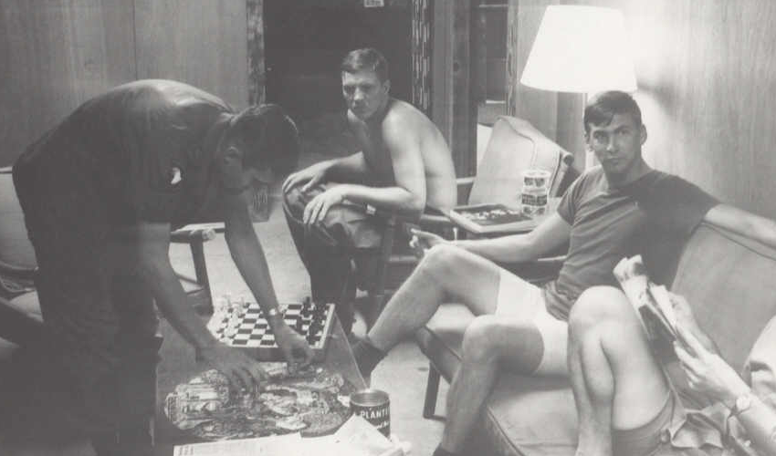
Co-Conspirators--
“Chicken Man” Honoring
Planning Session

Toward the end of my tour Col. Chicken Man was promoted to brigadier general. While the star hadn’t yet been pinned, it was official enough for a celebration. It was a command performance type of thing, arranged by his staff, to honor him. We had a local VN sculpt a LOCH out of war junk. We painted it a bright red (Transportation Corps colors) and planned a little skit. While he was being presented the vermillion helicopter (with paint still tacky) to tongue-in-cheek wording, someone shouted “Where’s the fire extinguisher to go with that”? Someone stepped forward an offered a small CO₂ job. “Is it charged?” the voice inquired. “Let’s see” was the response. With the horn tilted up 45º a short blast was triggered. We had filled the extinguisher horn with chicken feathers and they filled the room. There were too many of them to be really funny as they got into and onto everything. They stuck nicely to the slightly tacky paint of our gift helicopter—just like we had planned.
Having respect for command is important. But I have long since learned that you can only earn the respect of others, not command it.

Saigon Tour
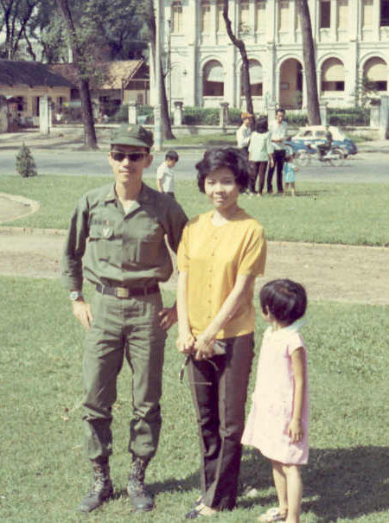
From time to time LCM’s full of VN troops would be in Cat Lai. One day I recognized a familiar face—a Vietnamese LT who had attended boat school at Ft. Eustis. He was in his 30’s and had a good sense of humor. He had been to our apartment in Newport News a couple of times. He was living in Saigon and we made a date for him to show me the town. We met at the appointed hour and, with a young niece of his in tow, saw the sights.
We stopped at a home that he identified as his father’s house—he was not at home. In the main sitting room there was a collection of very ornate carved, wooden furniture. The kind inlaid with mother of pearl. Very impressive. As we left, he said we would go to his mother’s place for lunch.
Lt. Dan, wife and niece
Where are they now?
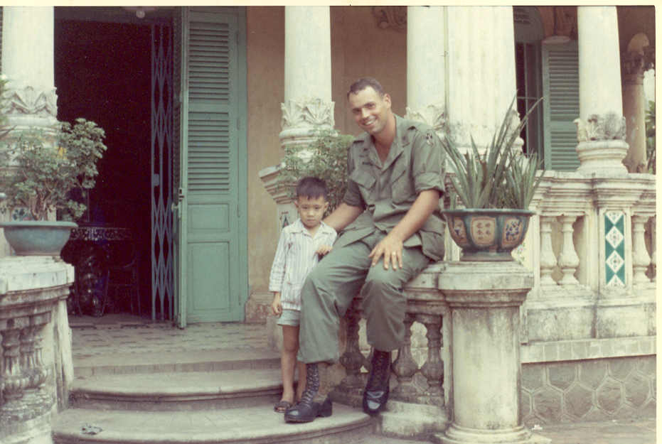
Confused, I asked why his mother didn’t live with his father. “My father has two wives” he explained, “We will have lunch with my birth mother.” Embarrassed, I told him I was as hungry as a horse having missed breakfast.

Lt. Dan’s Father’s Home
(Lt. Dan’s nephew)

His mom’s place was a small apartment. She was a tiny, old woman not much over 4 ft. tall. I sat on the couch and the low table was laden with things to eat—appetizers. The only thing I recognized by sight were the peanuts. They were raw, a taste sensation that leaves something to be desired. I was handed a full, 12 oz. tumbler of Scotch whiskey—straight up.
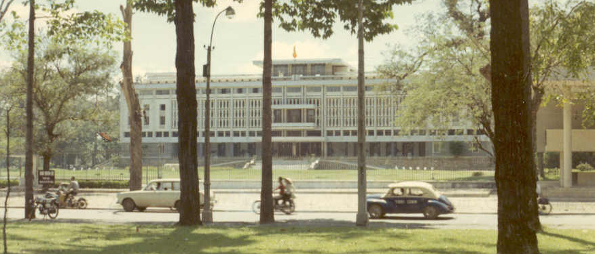
Presidential Palace--Saigon

After a while we moved to the table. I observed my hosts. We had some soup that was tasty. You had to finish it because the soup bowl was used for the rest of the meal. Platters were placed on the table family style. The main event was kind of like a roll-up. You would take a lettuce leaf and, with chopsticks, load it up with fried pork and various condiments. A splash of fish sauce (Nunc Mahn?), roll it up like a taco and eat it. It didn’t taste too bad. As I started to build my second, I was having trouble handling one of the condiments. It kept breaking up as I tried to lift it with the chopsticks. “What’s this?” I asked. “Cooked blood” was the answer.
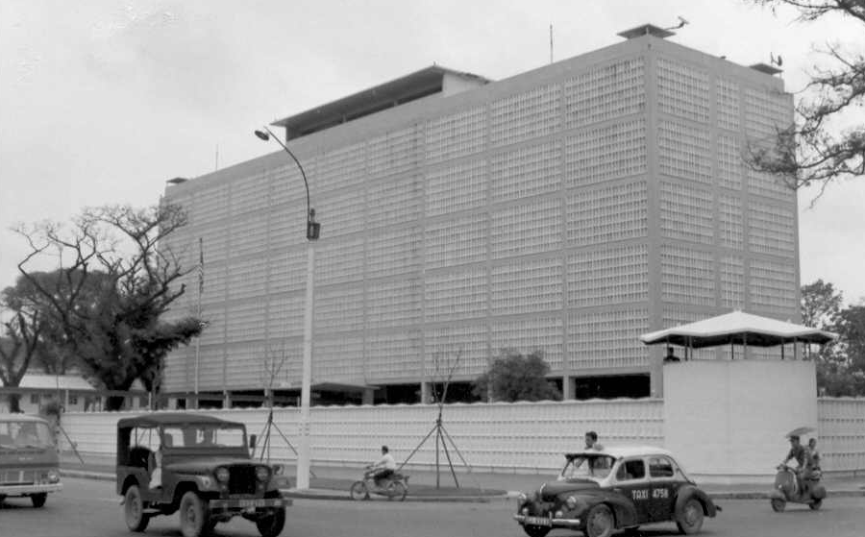
American Embassy
(no chopper on roof—yet)

I never knew your appetite could evaporate instantly. I was finished, but had not eaten very much. His mom went nuts. While I hardly knew any Vietnamese, her body language and tone of voice were unmistakable: “What’s a matter with this guy? Look at all the food I have prepared—he’s hardly touched a thing. Some one as big as him should be able to eat a whole pig!”
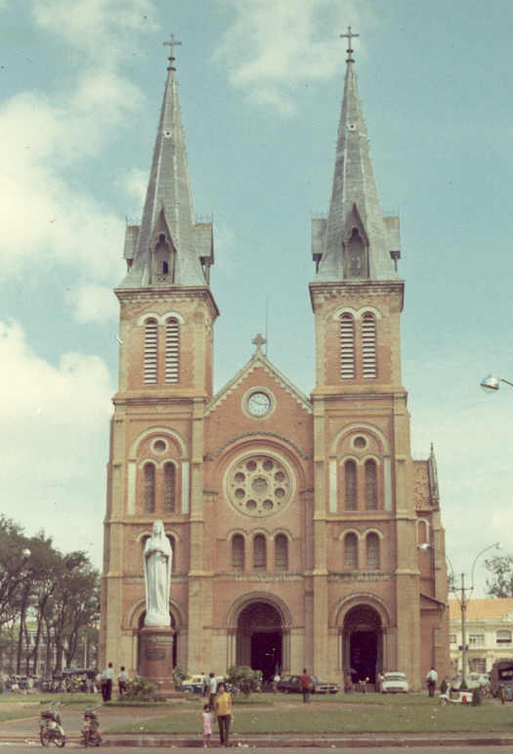
I recently learned from a Vietnamese immigrant some enlightening facts. An important aspect of VN culture is to go all out for their guests. Nothing is too much. The large full glass of booze is presented as an honor—you are not expected to drink all of it unless you care to. The alternative of a smaller, full glass or large glass with only a few ounces would be considered an insult. Further, I was told my friend’s mom was not mad at me. She would have been upset that she did not prepare something that I enjoyed eating. My repeated insistence that I wasn’t hungry frustrated her attempt to feed me well.
It proves two things: you can’t fool a mother and you can dress me up, but you can’t take me out.

Catholic Cathedral—Saigon

Askhim and Friends
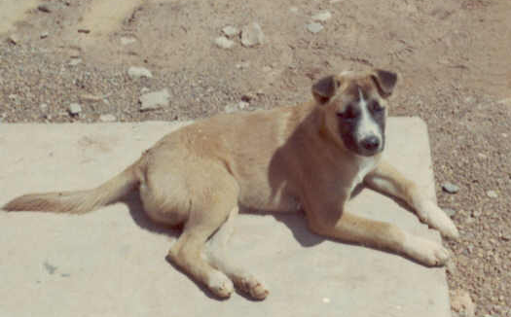
Loneliness is part of a GI’s life, so having a dog around is a real tonic. “Askhim” was one of the unit mutts in Cat Lai. On my first visit (as a self-important lieutenant) I found him sitting on my seat in the Jeep. Raising a hand and motioning for him to move, he bared his teeth and growled. My driver explained, “He doesn’t like officers.” How convenient (and humorous).

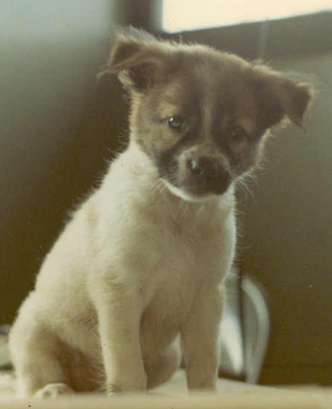
After we were properly introduced, the growling stopped and a friendship formed. When I asked how he got his name, I was told there had been a crusade to insure that the dogs had the appropriate vaccinations. When the Army Vet asked what the dog’s name was for the record, the GI said, “I don’t know, ask him.” And that’s what stuck. I also remember a pooch named DEROS (for Date of Estimated Rotation Overseas), and an interesting looking local breed. I think they were called Phu Quac dogs, having curly tails a distinctive whorled hair pattern down their spines.

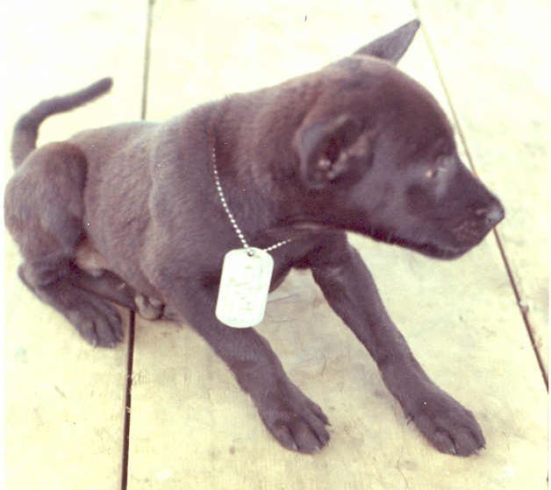
At one point, there were way too many dogs in the compound. Some genius issued an edict: all dogs without “papers” had to be removed. A short deadline was set. Separating a soldier from his dog is dicey business. The bond is strong and everyone is armed. The solution was to round up the dogs and put them in a landing craft where they were ferried across the river and turned loose. I swear, half of them swam right back across a swift river more than a mile wide. I suspect the
remainder were rounded up and brought back later. That was the end of the purge.

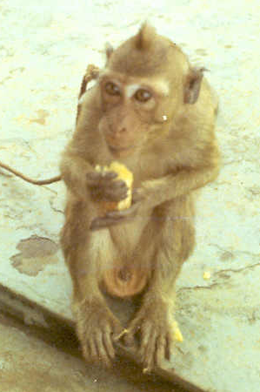
Zip—a Phu Quac dog

Jo--Jo

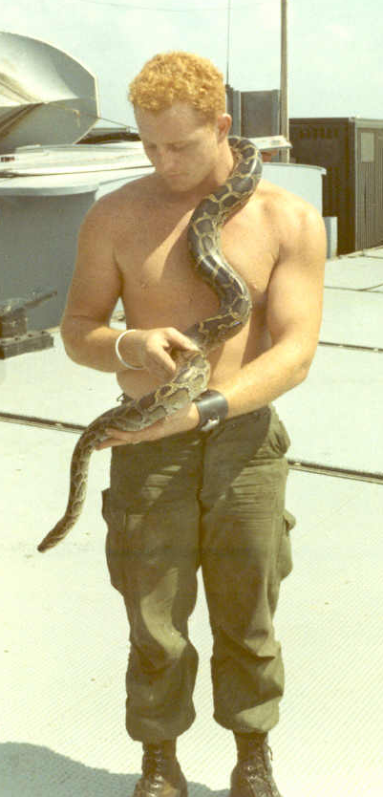

There was also a big mother of a pet boa constrictor and a monkey, named Jo Jo, in the Unit at one time or another.

Saigon Bound
I was moved back to Saigon sometime around November 1969. By then we had acquired two warrant officers, one of them was Homer Dawson. Both were maintenance types—they knew how to make equipment work.
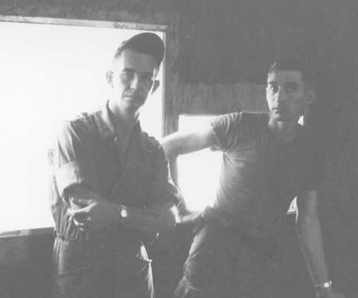
CPT Mancini (r)
WO Dawson (l)

Homer, an ex-navy chief petty officer was a good guy. Easy going, creative, someone you enjoyed being with. We were having a hell of a time getting parts for the Boston Whaler outboard motors. On two different occasions our requisitions were return coded “no such parts”. We’d research and find all the part numbers had been changed and do it all over again. Somewhere, we met a guy who had been in Da Nang. He recalled seeing outboard parts in a warehouse and thought they were being readied for shipment to the Philippines. “The Philippines?” we asked. He said no one had been requisitioning them, so they were declared excess. Excess, my foot! The real problem, we knew first hand, is no one knew what part numbers to use.

Build It and They Will Come
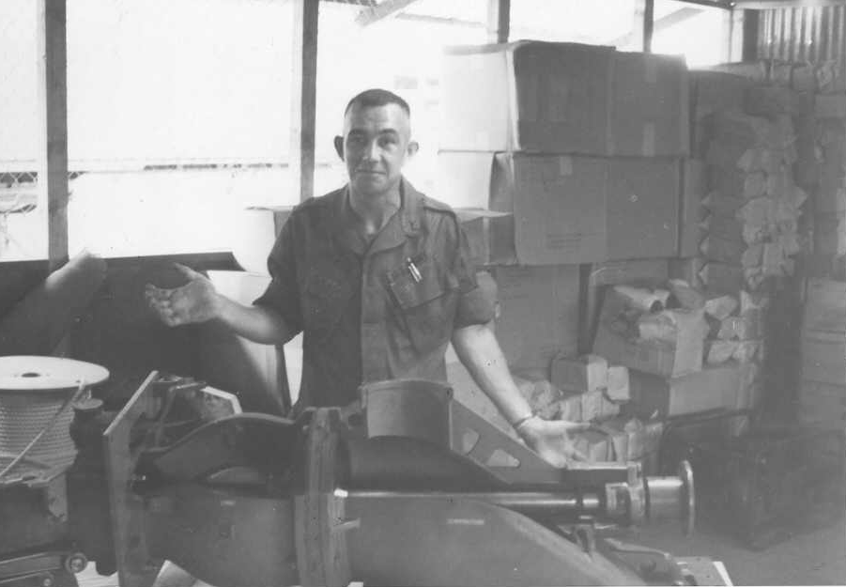
Traveling in country wasn’t the easiest thing to accomplish, especially when you didn’t exactly have permission. We had a Spec. 4 in Saigon that knew everything about outboard motors. Without authorization, we got him on a flight to Da Nang with the info on where the parts were located. His instructions were to see if we could use them and how we could get our hands on them.
Homer Dawson with
Jacuzzi training aid
(and lots of parts!)

Days passed; we heard nothing. The pucker factor increased with each passing day, especially since we were signing the Daily Report as “all present and accounted for.” Finally, after several days, a call came in. He apologized for not calling, but had been busy trying to “arrange transportation”. It turns out the Da Nang guys were more than happy to give the parts to anyone who could use them—no paper work necessary. The “transportation” was a C-130—it took several tractor trailers to handle it all. When the stuff arrived in Saigon, we had to build a building to store it all. We had desperately needed the parts, and now we had the market cornered.

Amazing what a skilled Spec 4, unencumbered by “procedures” can accomplish.

Saigon Living
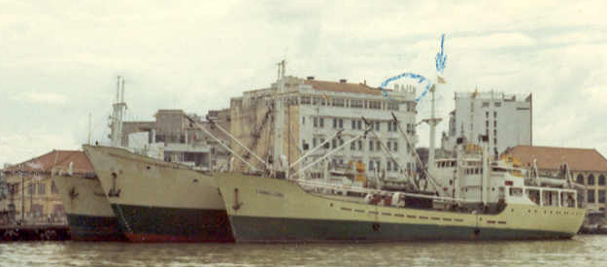
Our compound was near Ton Sun Nhut airbase. (Was it named Pershing Field?)It was adjacent to a VN Army post, a cemetery and what must have been a soccer field. It was not very large. There was a centralized mess hall, a barber shop and NCO/enlisted man’s club (I’m not sure which any longer). They were above ground latrines, built over removable, sawed off 55 gallon drums. The effluent was burned off each day with diesel fuel—an unforgettable stench.

Saigon Waterfront
Majestic Hotel behind ships

Vietnamese were employed to work in the mess hall, as hootch cleaners/launderers and other odd jobs. Neither side knew much of the other’s language beyond a few phrases. I remember the barbers. They would finish the haircut with a quick neck and scalp massage and then “crack” your neck. Holding chin and the back of your head they would twist you head to a certain position then give it a little flick. You could hear the vertebrae ‘Pop’. The first time it scared me; after that I looked forward to it.

Combat Volleyball
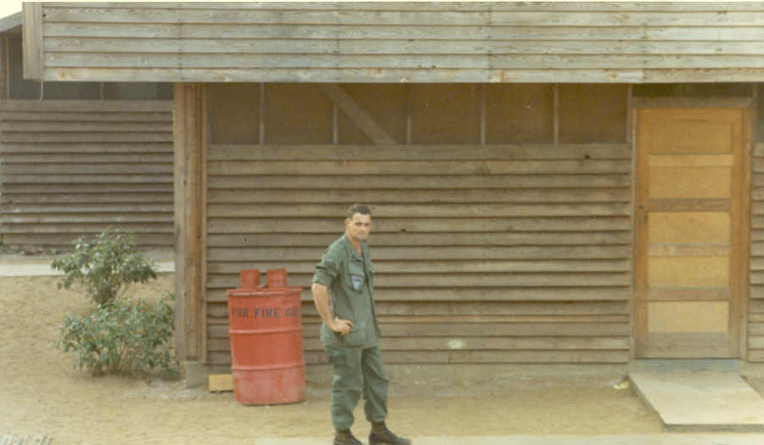
On Friday afternoons there was a habit of having an Officers Vs. Enlisted volleyball game—combat rules. It was rugged, but good fun. On one occasion, I was trying to make a save and landed full force on one wrist. I finished the game, but was in excruciating pain afterwards. That evening I went over to the main hospital in Saigon, which wasn’t too far from us. The X-ray was negative—it was just a bad sprain. I remember the doctor ordering the Medic to give me “X” cc’s of some kind of pain killer. “Doc, he’s not a horse”, the medic said as he rolled his eyes. The doc paused then cut the ordered dosage in half.

458th HQ Bldg/Supply Room

That had to be my first out of body experience. I don’t know what that drug was, but I felt great, and wouldn’t mind having it again from time to time.

“You Are Cordially Invited…”
“…to participate in a volley ball match in honor of the Tet Holiday. Refreshments will be provided.” Those, more or less, were the words on the formally printed invitation. The VN Army unit next door was challenging us to a volley ball match. They had to be kidding!
We may not have been athletes, but we were in pretty decent shape and twice the size of our challengers. It would be like taking candy from a baby. We accepted.
We arrived on a Sunday, starting around 11 AM. The initial introductions and “speachifying” were a little awkward, but everyone relaxed when play began. It was a best of three, 15 point match played on sand—something we weren’t used to.
In the first game, we cleaned their clock as if it were a varsity vs. junior varsity game. I don’t think they had more than 5 points on the board. There was a short break. They had a tub of iced “33” beer, it was hot, and we were off duty—why not have one.
The second match started out like the first, and then the wormed turned. They realized they couldn’t score by trying to spike it at the net—we were too tall. They started placing their shots. The match went to “duce” any number of times. Their resolve was tightening and we were wilting in the sweltering noon-day sun. When they scored the winning point, they went nuts. You would have thought they won the war. The match was even.
The second break was longer than the first. They served some snacks and more to drink; we obliged.
The third game wasn’t a match at all. They blew us off as soundly as we trounced them in the first game. They had one guy who could place his serve on a dime—and he did while facing away from the net. He was outstanding. He also served every ball for them that match. We complained that service was supposed to “rotate” but they feigned they couldn’t understand English very well.
In the end, we all ate and drank with the same gusto. They were gracious in their victory, having beaten the American gorillas.

Cyclos
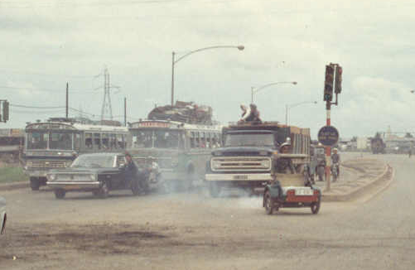
Fume Spewing Cyclo
(right front)

Cyclos are what you get when you motorize a rick shaw. Instead of a human being pulling a two-wheeled cart, the motive force is a 100cc or so 2-cycle engine. It, and the driver, is positioned behind the seat for two. The passengers become the front bumpers.
Saigon traffic was congested and noisy. Traffic signals were ignored—positioning was everything. If traffic was stopped in your lane, move to an open one even if it normally flowed in the opposite direction. At busy intersections, cross traffic would gradually ooze out into the flow and eventually “pinch it off” and gain the right of way and go like hell for a while. The stopped traffic would start to ooze its way out. It didn’t matter what color the traffic lights were.
It was noisy too. The whine of 2-cycle and the fume of the oil-gas mixture permeated everything. I recall seeing one family riding on a small Honda motorcycle: mom, dad and two small children—amazing.
We didn’t use cyclos much, but they were always a thrill to ride.

Thunder in the Night
It wasn’t really thunder. It was a sound that you could feel more than you could hear—a deep rumbling sound. You could feel it in your gut. Someone said it was B-52’s bombing Cambodia which wasn’t all that far away (about 30 miles). It was a sobering, disconcerting noise. I remember wondering what it must be like to be under that. How could anyone stand it? And yet, they did.

Entertainment
There were a few Officers’ Clubs in Saigon we could get to by Jeep. While not gourmet, the steak and potato meals and free flowing booze was always welcome. Some would have live music, meaning a Phillipino or VN trio with a female singer. They would pound out the popular music of they day. Most didn’t speak English, but they sang it, having memorized the words: “Oh baby ruv, oh baby ruv…” It wasn’t the Supremes, but it was close enough.
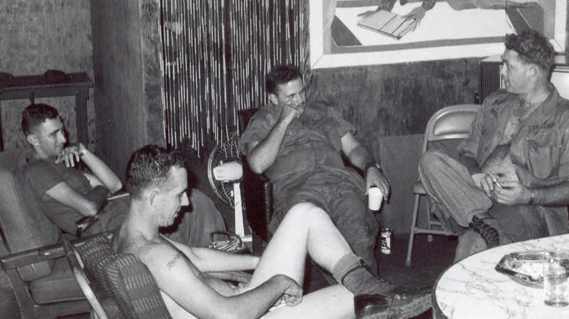
Kicking Back in the BOQ
Mancini, Dawson &
Two NCO’s

One evening, our entourage included an MP Captain, me, another lieutenant and a young driver—a buck sergeant. When we arrived at the club, the captain (already lubricated) said it was unfair for the sergeant to sit around and wait for us. We had enough extra gear to outfit the sergeant as a captain. He was very nervous about getting busted for “impersonating an officer”. We assured him of our protection. The captain developed a taste for Crème De Menthe and drank most of a bottle by himself that night. The E-5 loosened up and began to enjoy the feel of being a captain—to the point of “pulling rank” on us lieutenants. We had a good time just enjoying each other’s company.
Drinking yourself into bed at day’s end was pretty routine. While booze was rationed, plenty was available. I developed a fondness for Vodka Gimlets, with extra olives. A small bottle of Rose’s lime juice cost $3.50. A quart of good vodka cost $.90—no wonder we drank so much.
As a side light, a friend of mine noted how common it was for officers to get hammered fairly regularly, then struggle the following day to sober up, and that was OK. In contrast, the GI’s would get wasted smoking grass but be relatively fresh the next day—but that was illegal. Go figure.
I remember stirring to life in our hootch early one “morning after”. WO Dawson plodded out from his cubby hole looking like a zombie. He set a glass of water on our small, cluttered bar and struggled to open an alka-seltzer packet. “Plop—plop” he deposited the two tablets into a quarter full glass of stale beer sitting next to his water glass. As they fizzed away, he waited, hanging on to the edge of the small bar with both hands. After a few moments, he picked up the glass of water and slowly drank it straight down. Setting the empty glass back on the bar, he belched mightily, announcing “Now I feel better.” He turned and padded back to his room—the alka-seltzer still fizzing in last night’s beer.
Mind over matter—exhibit A for the placebo effect.

Movies in the Mess Hall
Once a week or so there would be a movie in the mess hall in Saigon. I recall watching Stanley Kubrick’s 2001, A Space Odyssey. It was a weird movie in a weird setting. I’m still trying to figure out the ending.

Radar O’Reilly
Our company clerk was kind of like radar—always anticipating. One day he presented an idea. We wrote the Pabst Blue Ribbon Company a letter. We pointed out the similarity of our unit’s name (PBR) and the common name for their beer. With great verbal flourish, Radar went on to inform them that we had officially named them our Unit Beer. Further, we intended to conduct a special ceremony to commemorate the honor and suggested it would be appreciated if they would ship us a pallet of beer to mark the occasion. It was masterfully written.
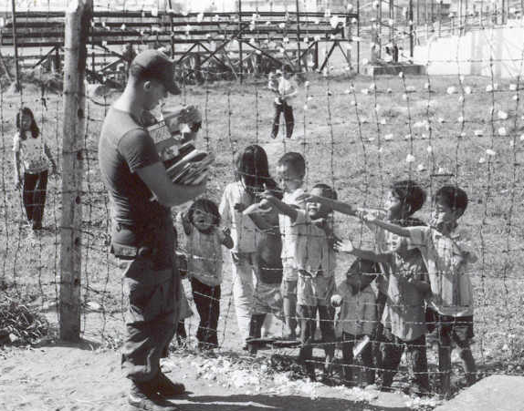
They responded. An equally skilled wordsmith went on and on about how grateful they were to be so honored. Unfortunately, they were concerned with the logistical challenge of shipping us a pallet of beer. Regrettably, they couldn’t manage it. However, they hoped we could find good use for the enclosed gift. Inside the small box was one gross (144) Pabst Blue Ribbon church keys!

Company Clerk distributing excess pogey bait from home to the neighbors.

R & R
After about six months, everyone got a 7 day R&R. It was a brilliant idea as it offered something to look forward to and a much needed change of pace. Hawaii, Australia and Thailand were popular destinations. The Aussies were particularly friendly to us “Yanks”. One GI retuned to the unit from down under and spoke in awe of his experience. He said he left the airport and found a bar. Once inside, he couldn’t pay for a drink as they were lined up in front of him. Someone invited him to their home and hosted him for the length of his stay. He looked at me with disbelief and said he returned with as much money as he had left with. Now that’s what you call hospitality.
My young bride was teaching full time, so we arranged to meet in Hawaii between Christmas and New Year. I tried to get a place in Maui, but it was impossible during the holidays. Since this was all done by letter, I was getting desperate. Finally, I wrote the Royal Hawaiian Hotel on Waikiki beach and pleaded. The only thing I requested was “the biggest bed you have”.
The flight to Hawaii was and experience. Word of mouth had everyone prepared. You were to be in proper uniform and look sharp. (There were rumors of picky MP’s refusing to let guys board if they didn’t pass muster.) The plane was full. As we rolled for takeoff, you could cut the air with a knife. When we lifted off there was a spontaneous round of applause. In a few minutes you could see the coastline recede below us as we headed east.
I was seated next to a sailor dressed in his white jumper and bell bottom trousers. He was blonde with a deep tan and a huge bandage on his face. It completely covered his nose and upper lip. I felt sorry for him, wondering how the bandage would interfere with the “close-in facial maneuvers” that awaited him in Hawaii. Once the flight was comfortably underway, he climbed over me and headed to the can. On his return, he was completely transformed. The bandage was gone, and in its place was a spectacular blonde, handle bar mustache! He explained that while the Navy permitted facial hair, he had heard stories that the MP’s insisted on clean shaven faces as a condition of boarding. The bandage was his camouflage to protect his mark of distinction.
Needless to say, everyone on the plane was in good spirits. The stewardess’ started a pool to guess their average age. But the real point of interest was the co-pilot.

Topless Coffee Service
A voice came on over the intercom and identified himself as the co-pilot. He gave the usual flight info and explained that they had flown in the day before, overnighted in Saigon and understood the importance of this flight to each of us. In the effort to depart exactly on time, they had one problem—the navigator had missed the flight. It had been easy so far, but now that the coastline was out of sight, it was a little trickier. He asked everyone in the window seats to keep their eyes pealed for other air planes or ships and encouraged anyone with navigation experience to feel free to come forward. Crazy!
Awhile later, he appeared at the front of the cabin and identified himself. He acknowledged that had the navigation issue under control and everything was going smoothly. So smoothly that the Captain wanted to catch a nap, and therefore had kicked the co-pilot out of the cockpit. He went on to say that on long flights like this (we were headed to Guam for refueling) there’s no reason for everyone to be bored. He then outlined a contest: Everyone was invited to sculpt something out of the various materials that accompanied your on-board meal. Three civilians (embassy personnel, I think) sitting in the front of the plane were named as judges. The winner would receive “topless coffee service”.
Everyone was electrified, the creative juices stirred and the prospect of topless coffee service boosted the air temp on board by at least 5 degrees. One by one GI’s carried their works of art forward for judging. I remember one guy had made something that actually looks like a Huey. Finally, a winner was chosen and escorted to a seat in the rear of the plane. An absolutely drop-dead, gorgeous blonde appeared at the front of the cabin holding a tray with the coffee service. With a big wink and some flourish, she disappeared behind the door to the cockpit. The air temp rose another 5 degrees.
Finally, the intercom crackled with a female voice asking, “Are you ready boys?” The plane shuddered with the affirmative response. The door came open and out walked the topless service. The copilot had stripped to the waist and strutted down the aisle with great flair to keep his end of the bargain. The humor of it all put everyone totally at ease.

New Year in Paradise
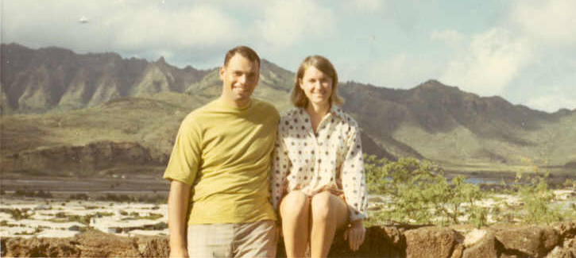
Lois and Me
December 1969

The arrival drill at Ft. DeBussey was something. The new arrivals were seated in the auditorium, with loved ones lining the perimeter. A JAG Captain hustled out and gave the mandatory spiel: watch out for thieves, don’t get arrested, ask for a GI discount and, most importantly, DO NOT miss your return flight. I have yet to hear anyone speak as rapidly as he did.

Once dismissed Lois and I hooked up in a hurry. We found or way to the Royal Hawaiian where we had a room with the biggest bed we had ever seen before or since. It was very—shall we say—comfortable. We spent the week doing the usual Hawaiian things, but mainly just hanging on to each other.
Our day of departure was New Year’s eve 12/31/1970—our flights separated by about an hour or so just as the new decade was rung in. It was another hard goodbye.

Officer of the Day
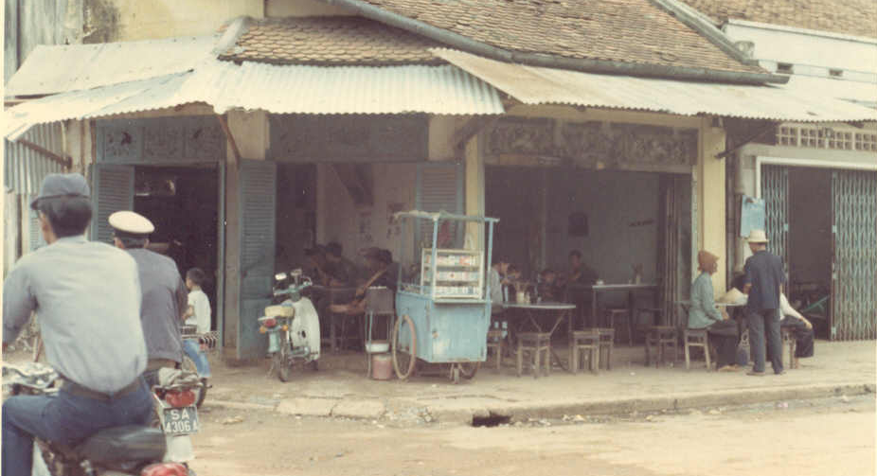
Someone always had to be on deck at the BN HQ, so nights and weekends the “OD” duty rotated among the junior officers. Not much ever happened, but you were to keep tabs on things and, when a mess developed, decide whether it was worth waking the battalion XO or CO. One night a call came in.
Typical Saigon Street Scene

There had been an explosion in the Cholon section of Saigon. There was a bunch of property damage; no one had been injured. The explosive ordnance disposal guys wanted the MP’s to come down and look at something. While on the way, another call came in; there had been a sound like an explosion on the Newport Docks. The strange thing was, nothing seemed out of order.
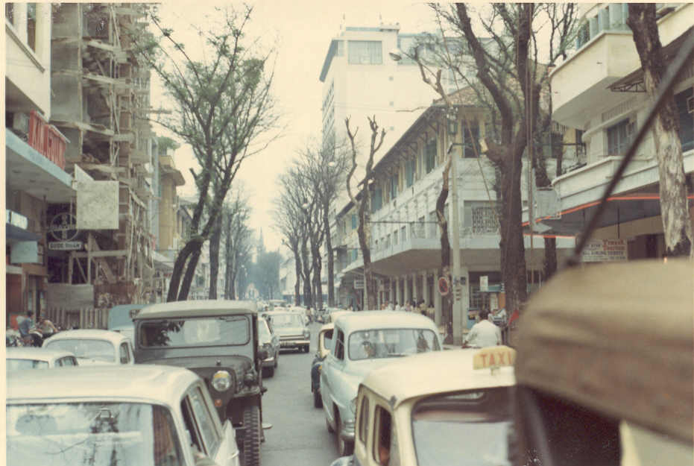
Saigon Traffic

The EOD guys laid some of the “evidence” out on the table. It looked like scrap metal to me. They had identified it as a standard high explosive round from a US tank. Oh—oh. After a lot of head scratching, we came to no conclusion. The closest US armor unit was too far away to account for the incident.
We continued on to the Newport docks on the Saigon River. The suspicious sound was reported to have come from the waterside of the dock. A merchant ship was tied up, and there were several barges loaded with ruined armor equipment to be hauled away for scrap. On one barge sat a tank that had been partially blown up. Its gun tube was at an awkward angle pointing into the night sky. We checked a map, and sure enough—the tank was pointing exactly in the direction of the mysterious explosion. We had found the smoking gun—literally.
There was no activity on the dock, only a light guard was posted. I asked that they be assembled. Once they were lined up, it became obvious. One guy looked like he had seen a ghost. He explained that he became bored and went onto the barge to check out the tank. He crawled inside and, in the process of fiddling around, BANG—a round fired. He ran fearing the consequences. I don’t remember how I wrote it all up, but I suspect these paragraphs say more than the log book for that night.

Road Trip
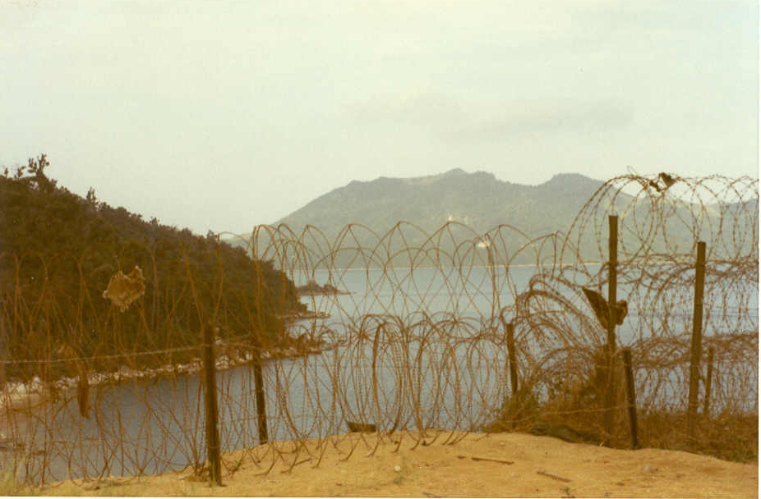
A “FUBAR” View
Of Vung Ro Bay

As Company XO, I had the opportunity to get to all our unit outposts. I barely remember the trip to Quin Nhon but have a vague recollection of the pier and traveling through Danang. Vung Ro Bay memory is more vivid. It was monsoon season, and the weather was miserable. I hitched a ride on a convoy that brought me overland to the harbor. Coming to the top of the ridge, it looked like a moonscape. Trees had been blasted and defoliated—it was eerie looking. Just over the ridge, the small harbor looked like a jewel, with its single pier jutting into the water.

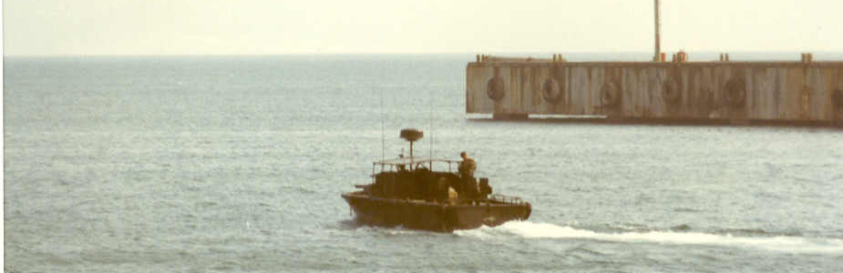
As I recall there was a small pipeline to handle petroleum, and general cargo was offloaded and convoyed out. There was occasional guerilla activity in the area which kept everyone on edge. A Korean infantry unit was stationed nearby. Someone egged me on to try their C-rats—my first encounter with kimshe. No thanks!
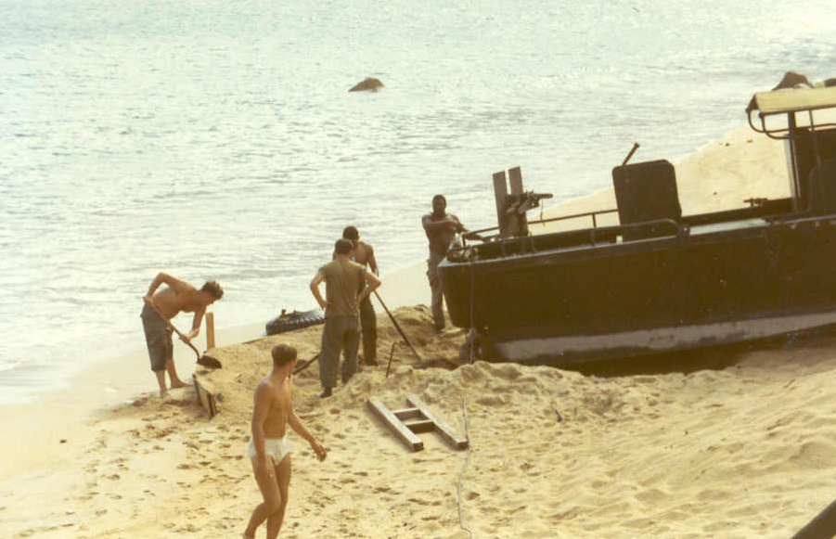
Need a Dry Dock?
Wait—I’ll dig you one!

The 458th had two boats assigned—one always seemed to be out of service. When I arrived, it was on the beach for hull repairs. The crew quarters were something to behold. The hootch was right on the beach and very nicely done. I mean there were curtains, AC, lamps, decorations. I was flabbergasted. When I asked where the stuff came from, I was told they purchased it. Where did the money come from, I asked. From the beer, was the answer offered. As the story goes, one ship was carrying PX supplies. “Somehow” a pallet of beer may its way via PBR to the shore. The men decided to “sell it” to themselves and use the money for home improvements. Ingenious.
I’ve never had the urge to return to Viet Nam, but if I did, I would like to stand on top of that hill and look down on Vung Ro Bay again.

C-Day
That was the drill we went through in the attempt to stifle the black market co-opting the use of the military scrip. What a headache. The war effort was supposed to stop as all the troops were to turn in their “old” money in return for new. There were some rules in the event a soldier tried to convert an “excessive” amount of money. There was an E-5 supply sergeant in Saigon who had a whole pile of money, so the alarms went off. He claimed he was very good at poker, but would not offer names of those he supposedly fleeced. Most of his pay was being sent home, so there was no way he could have saved the amount of money he was trying to change. CID was called in, and they got absolutely nowhere. He was a likeable fellow, and handled his responsibilities well. When I would probe him, I’d just get a smile.
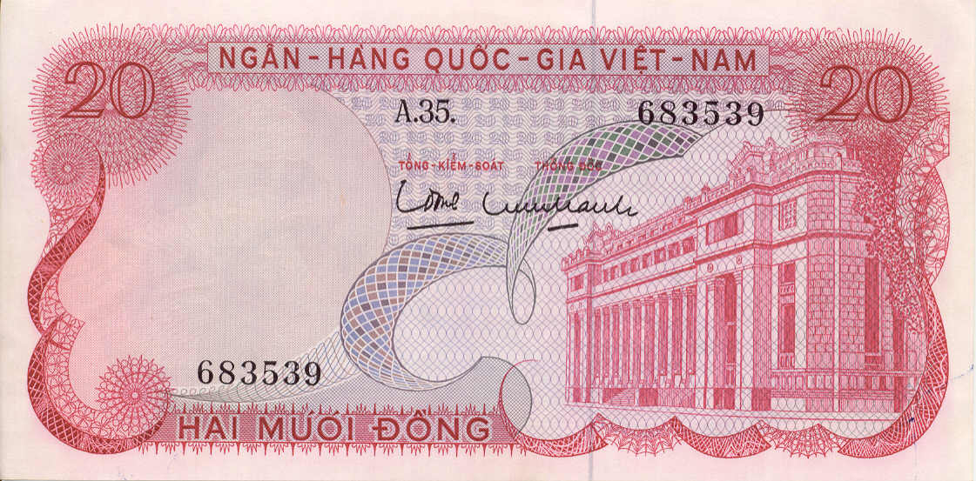
Twenty “P” Note—Worthless!

After a month or so, his DEROS was approaching. CID asked that we not cut orders for his return to the states. He was frantic, wanting to get out of Dodge. The CO was away, so the decision was mine. The CID guys didn’t have anything to go on—just their suspicions. I couldn’t hold him in that country any longer than necessary, and signed his transfer orders. In my mind, he had a couple of years left on his hitch. If the MP’s found something bad, they knew where to find him. What do I think? I think he was—well, never mind. It doesn’t matter any more.

Wrecked Jeep
When equipment was damaged to the point of replacement, an investigation was necessary. That is the only way you could get it replaced. I was assigned to investigate a jeep wreck. Two MP’s, returning to the compound after a 12 hour shift, went off the road and totaled the jeep. They were OK. When I arranged to interview the driver, he was scared stiff—knowing that if he were found to be “reckless” he could wind up paying for the jeep. The facts of the matter were that these guys had been putting in excessive hours and were exhausted. I asked him to watch carefully what I was about to do, and proceed to tear up the investigation forms. His eyes were as wide as saucers.
I explained to him how initiating the investigation was enough for his Company’s supply officer requisition a new one. It didn’t matter to him how it turned out—one way or another. I pointed out that I would be gone on a month or so, and that he wasn’t far behind me. Bottom line: by the time someone figured out the investigation was open and the papers lost, we’d both be long gone.

Bugs Eye View
Once a week, C-130’s would fly low over Saigon and spray the city—for mosquitoes I imagine. I know that bug repellant was ever present, but don’t remember them being much of a problem.
The radio shack at Cat Lai had wood siding. I remember a radio operator spraying between the ship lapped slats. The cock roaches poured out in waves. Ugh!
On a number of occasions, I flew by light observation helicopter between Saigon, Cat Lai and Vung Tau. The view from altitude was awakening. The rivers streams and canals were everywhere. Water was the major means of transport—not highways. Bomb craters pocked marked the countryside, marked by the reflection off the water that filled them. Also, there where the marks left by the defoliation chemicals—spray marks on the landscape. It made me wonder what it looked like before the fighting.

Red Neck Revenge
One day the BN XO called me to his office. This was the same guy that had me over the coals for the “excessive water in the bilge” incident. His tour was wrapping up, and he had received his stateside assignment. “Where’s Indiantown Gap?” he asked. He was going to head up the stockade (military jail) operation. With a straight face I responded, “Who have you pissed off?” He stiffened, with a certain sort of anxiousness, and wanted to know why I responded that way. I kept the charade going, telling him that Indiantown Gap (which I knew nothing about) was the arm pit of the state of Pennsylvania, and that he would be well advised to call in his markers and try for a reassignment. He was distraught; I had my sweet revenge.
Coincidentally, after I returned home, I had to go to the Gap to file a claim for the household goods that had been stolen from storage. Without an appointment I went to his office. His civilian secretary announced me over the intercom: “Mr. Wonsiewicz is here to see you—he said you would know who he is.” I could hear his voice, “Wonsiewicz? Wonsiewicz?...I’ll be damned! Lieutenant, get your sorry ass in here!” he barked.
We had a nice visit. He said that the Gap was turning out to be the best assignment he had had. “Why we even have TWA service here”. I was confused, since it’s not a big post and mainly handles helicopters and small engine aircraft. “Teenie—Weenie Airlines, we call it.” He explained there were a lot of reserve pilots looking for hours, and he was always looking for a weekend in Arkansas (or wherever). It worked out to mutual advantage.

How Many and a Wake-Up?
There wasn’t a soldier in Nam who couldn’t tell you exactly how many “days and a wake-up” they had until their 12 month tour of duty was complete. Many kept a standard issue Julian calendar to ceremoniously cross off each day as they elapsed. As your DEROS date approached, anticipation built. During my tour, the US was in the process of turning units over to the ARVN and reducing forces. It was a numbers game. Apparently, the headcount was on the high side, so the procedure to “catch up” was to allow troops to leave before 12 months were complete. There was always a buzz surrounding what the “number” was—the number being the days you could leave early. When the time came, orders were cut, which became the vehicle for getting you a seat on a flight “back to the world”.
For the longest time, the “Number” hovered around 30 days. I corresponded with home and gave them the news—and approximate date was set. It was not to be.
When my time came, there were no orders. Capt. Mancini explained that there had been too many troops bugging out early, so they had put the clamps on: no one could leave before their DEROS date. He knew I had been careful in making my plans, but could do nothing to help. He looked me dead in the eye and told me if I could find a way out, he would not stand in the way.
I quickly learned that a 1st Lieutenant has absolutely no pull whatsoever. I climbed the chain of command as high as I could but came away with little more than sympathy and a pat on the head. On the day I had expected to be home and reunited with my family, I was in Saigon making a phone call home to tell my wife I wasn’t sure when I’d get there. What a rotten day that was.

Ice Cream = Tickets Home
After the phone call, I returned to the compound. I had missed lunch, but managed to get a plate in the mess hall. Sitting by myself, the senior mess sergeant came by to chat. He sensed my mood and asked what the problem was. I recounted my tale of woe. He said that he was coming up on the end of a 2 year hitch, and thought it was time to head back—kind of the way you’d talk about heading home after a few beers with the boys at the local gin mill!
Do you have a jeep lieutenant? I did. He loaded some stuff in the back, and off we went. For the next couple of hours we went from one hole in the wall unit to the next. At each he would trade some of his stuff for some of theirs. Finally, we headed for Ton Son Nhut. Pulling up to a shanty, he remarked that this was the dispatch office, and that they controlled the flight manifests—the passenger lists. I offered to go in with him, but he suggested I stay put and watch for his signal—then unload the stuff we had collected at the back of their shack. The signal came, and I complied. He walked out in possession of the papers necessary to get us both out two days later.
I’m not sure exactly what he had bartered, but I remember there was ice cream and shrimp involved. Unforgettable.

Leaving From Bien Hoa
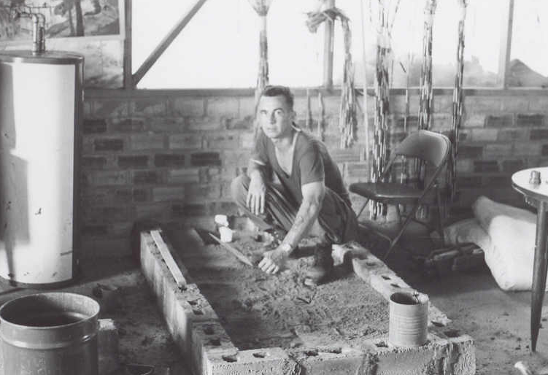
My memory is fuzzy on this, but I believe we had relocated the CO HQ to Bien Hoa just before I left for home. I clearly recall Homer Dawson building himself a bath tub. He built it out of masonry and finished it with fiberglass. He even had a rubber ducky to go with it.
Dawson & Bathtub
The heat did him in!

I also remember that as hottest temperature of my entire tour. The heat was really oppressive. I also recall being very anxious that something was going to happen and I wouldn’t make it home. Paranoia, I suppose.

Homecoming
The out processing at Oakland couldn’t go fast enough. The medical checks revealed that I had a significant hearing loss. While it recovered somewhat, I still have a constant ringing in my ears that’s getting louder all the time.
I caught a red eye flight through Chicago and Philadelphia to Allentown. The last leg was only 60 miles, so the puddle jumper never gained much altitude. I can remember the early morning sun side lighting the blossoms in the fruit orchards. It looked absolutely gorgeous. I swear I can remember smelling their fragrance-even if it was imaginary.
My family was there to greet me and it was a joyous moment. Once again, I could join with my young wife and relax without fear. I had made it. I was safe.

Afterword
I am ever grateful that I had the opportunity to serve in the Army. I am a better person and citizen because of it.
After leaving the service my life became very busy. Lois and have raised two fine sons, she has had a great career in teaching and I have had success in business. As I approach 60, I find myself reflecting more on my military experience—I suppose as a way to connect with what our country faces today. I’m no longer a warrior, (unless they need someone to head up a squadron on the Susquehanna River to protect Three Mile Island) but I am trying to be a citizen patriot. What I have found is that most folks in our nation have not been in the service. So, I try to teach and explain what I can. It makes me feel good to do so. We live in a time when there is plenty of interest in and respect for the military. That is a good thing.
But I have regrets too. I wish I had been wiser in 1969. Maybe I could have taken better care of my men.
And I regret that I can not remember the names. I can see the faces in the fog of my memory, but the names are gone. It especially pains me not to be able to remember the name of the crewman who died while assigned to Cat Lai. He was too young to spill his life out on the deck of that boat. I would like to go to Washington and put my hand on his name on The Wall—I would like to talk with his family.
But I do not regret what we were trying to do—trying to give the Vietnamese a chance at democracy, a chance at freedom. I am proud of that and sure that it was a worthy cause—despite the outcome.
In May 2002 some of the guys from my OCS class (Alpha 508) had a reunion. It was a powerful experience. Hardly any of us had been in touch, but after 34 years we are still brothers.
And so, to all of you who read this and have shared the common experience of duty with the 458th, I salute you. And to those of you who read this and have not had the common bond of PBR duty—read gently. Be respectful in the way you treat these memories, they came at a precious price.
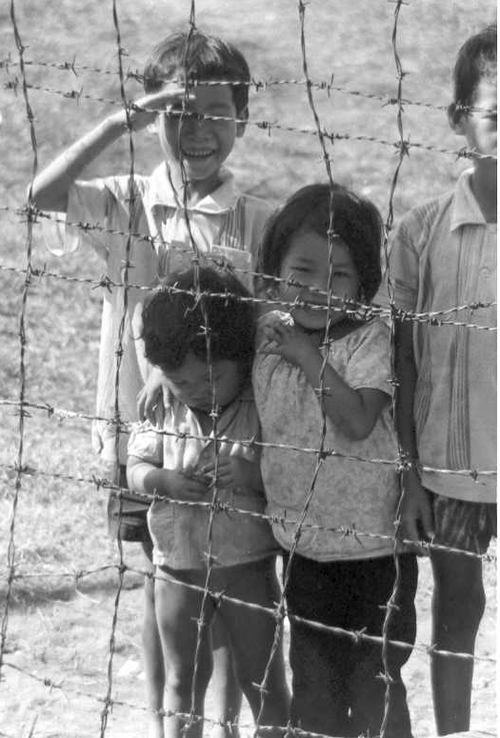

(2-29-04)

Photo Appendix

Saigon River Scenes:
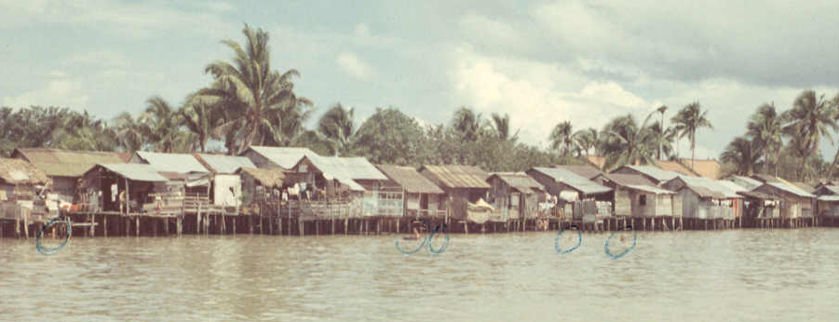
Shore living opposite downtown Saigon

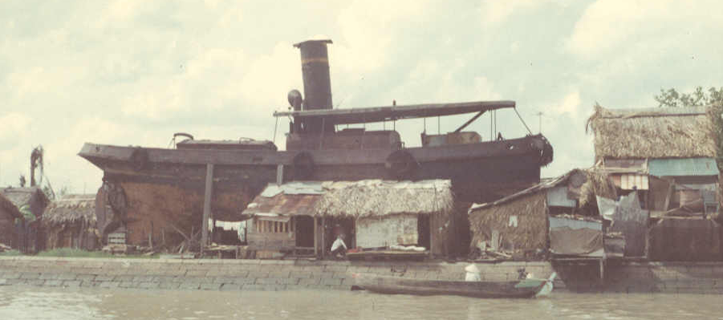
House Boat—literally!

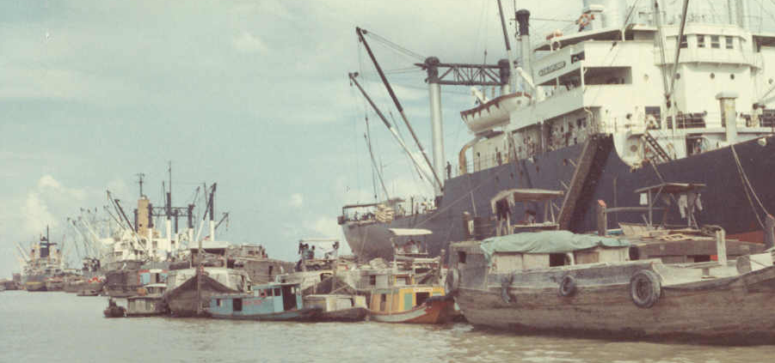
Commercial Lightering—downstream from Newport Docks

Saigon River Scenes:

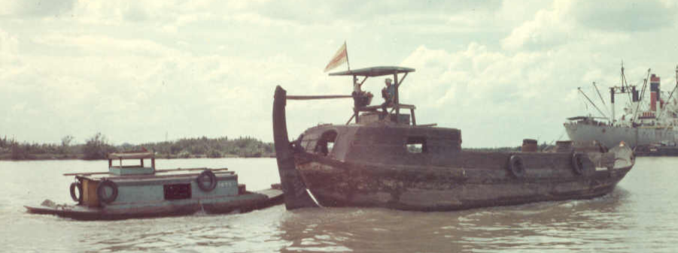
Saigon River “18—Wheeler” Equivalent (running empty)

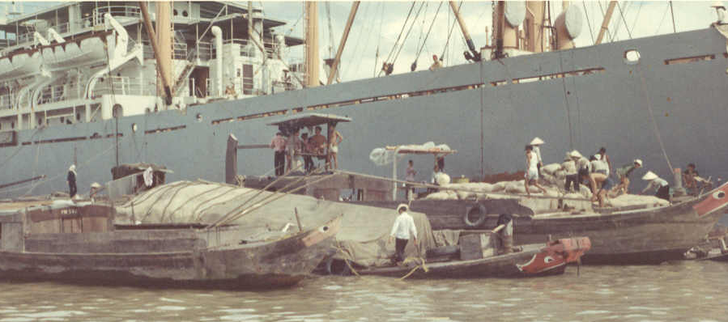
Junks being loaded—one in middle is full (no freeboard left)

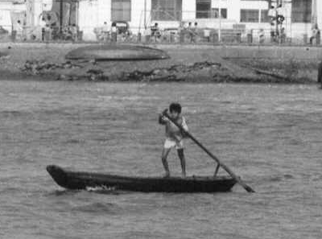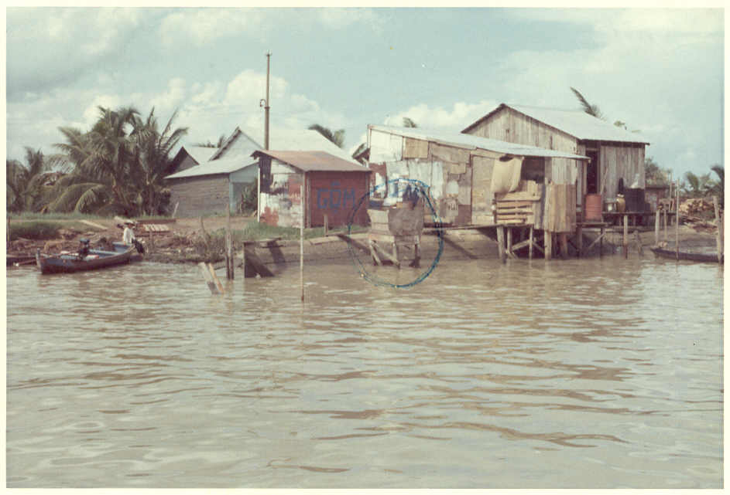
Like a bicycle River Living—Latrine and washing facility

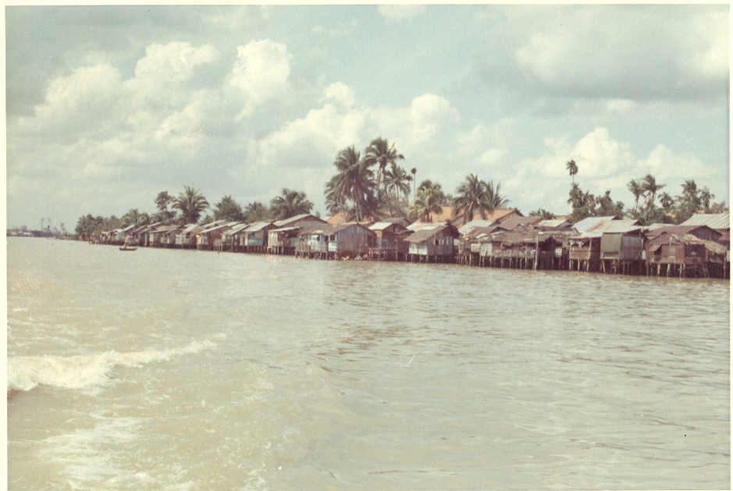

Note: In the early 1990’s my nephew visited Viet Nam as part of a “Semester at Sea” aboard a ship. He traveled the same waterways, visiting Saigon and Vung Tau. Though more than 20 years had passed, his river bank photos didn’t look much different. Go figure! (TJW)

Saigon City Life

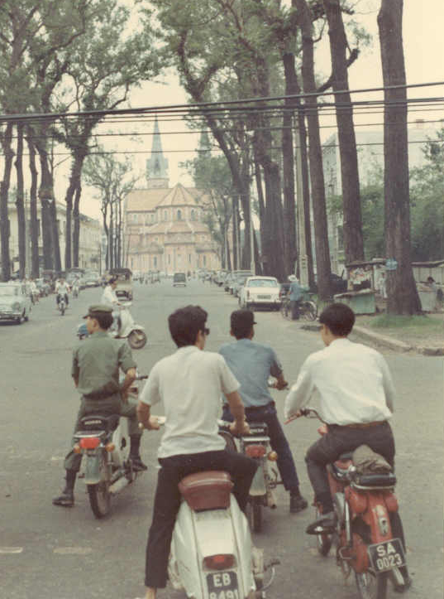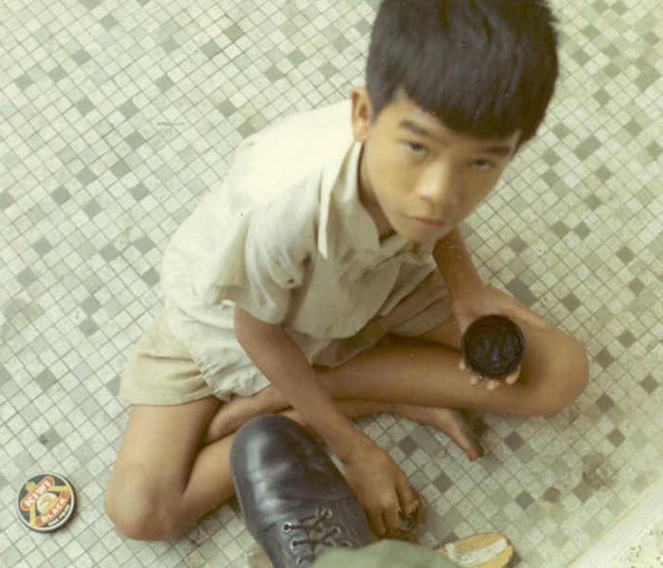
Going to Church? Shine mister?

Pershing Field Camp Kids

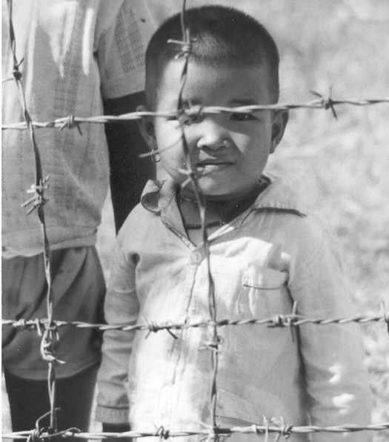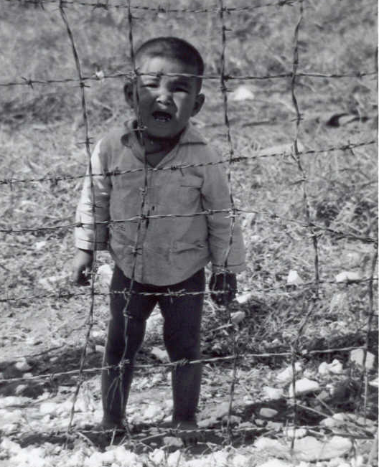

Happy? Not so happy!

Camp Kids (cont.)

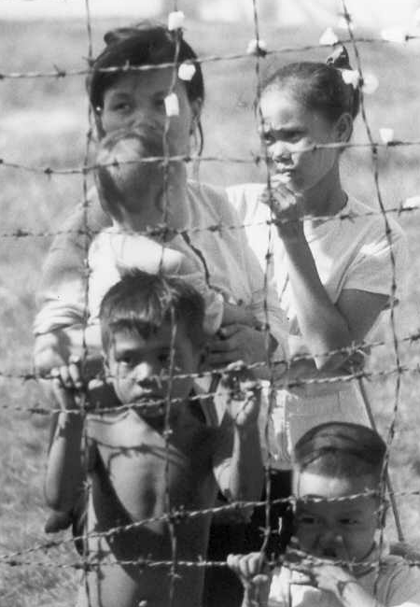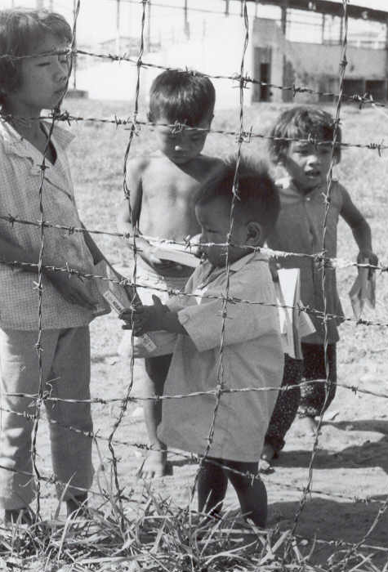
Young Mothers Amer-Asians?

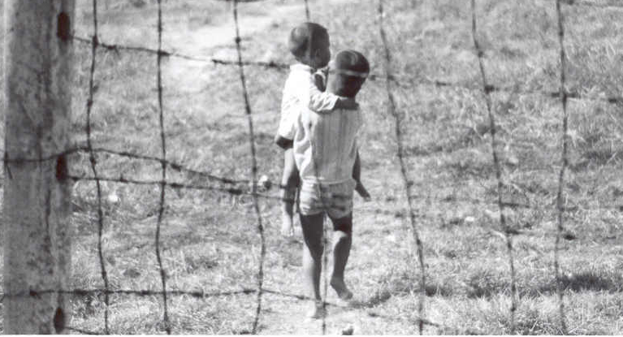
Brothers
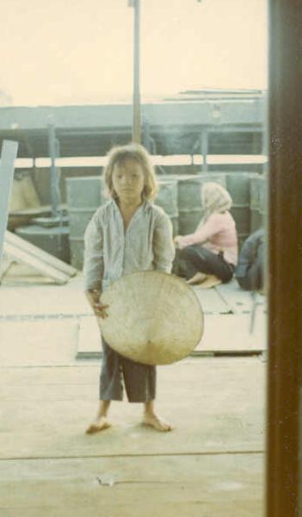

This little girl—7 or 8 years old, was part of the Cat Lai lumber stealing gang. I put a band-aid on her cut finger and made a fast friend.
Her natural curiosity penetrated the moment.
She simply was interested in all the things she had never before seen.
She’d be about 42 years of age now.
What are her memories?

Vung Ro Bay Scenes

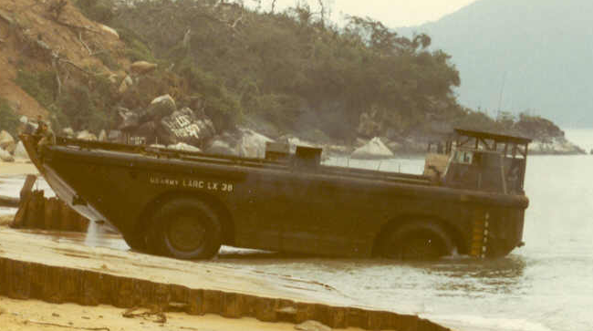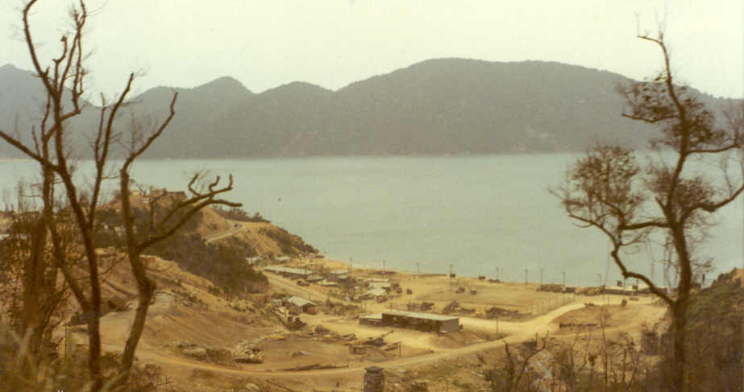

LARC Emerging Base Camp from Ridge

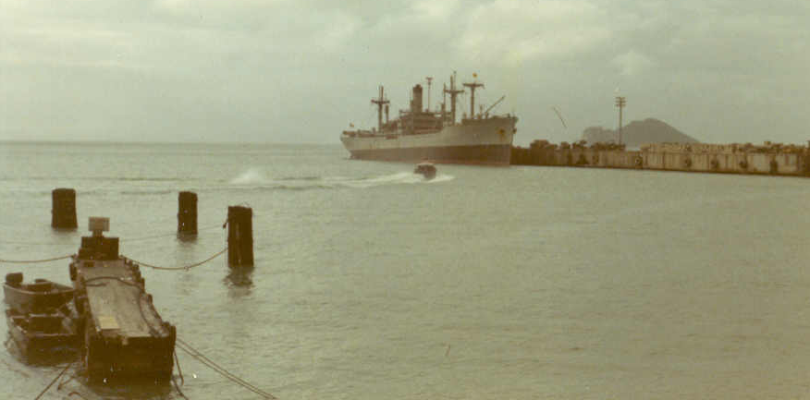
Incoming Cargo

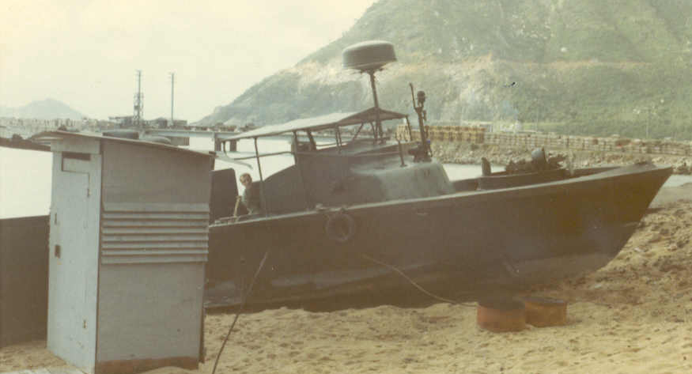
Fixer-upper, convenient to latrine.

Cat Lai Scenes
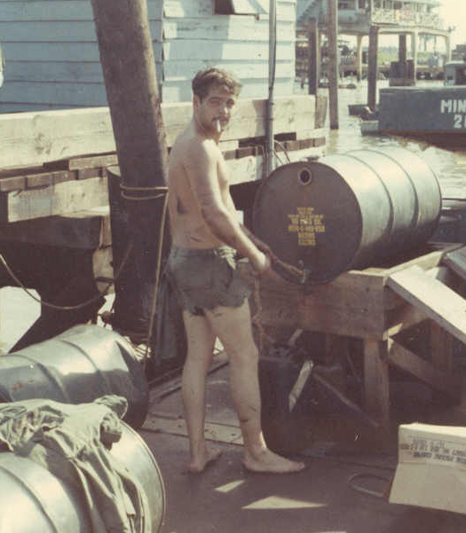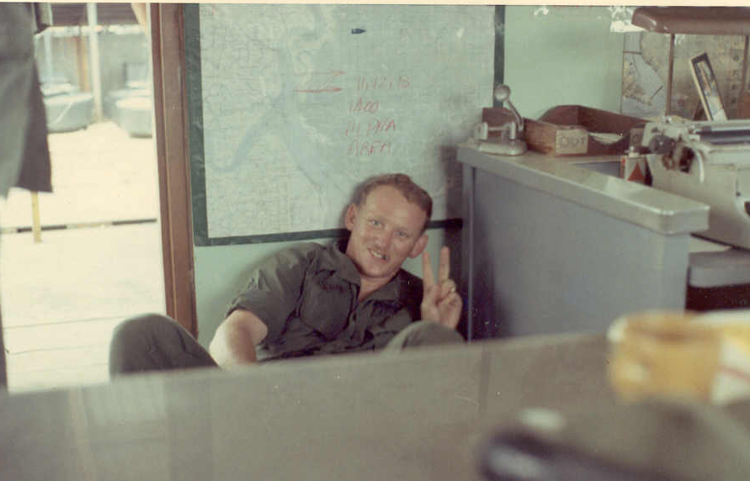
PFC John Mancino—oil change SP4 Larry Faubion—a political statement
(It was easier to clean skin than uniforms)
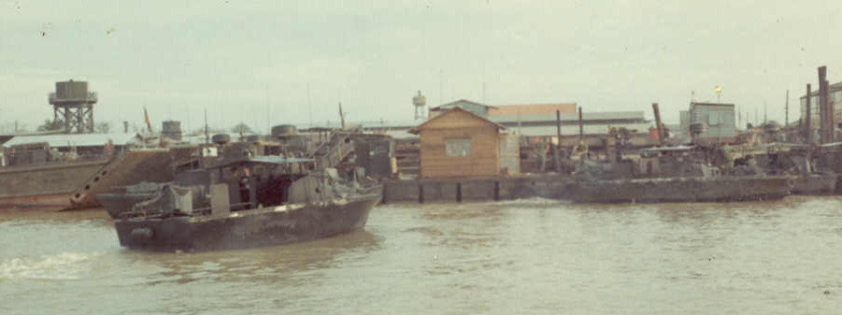

Approaching the Cat Lai Barge
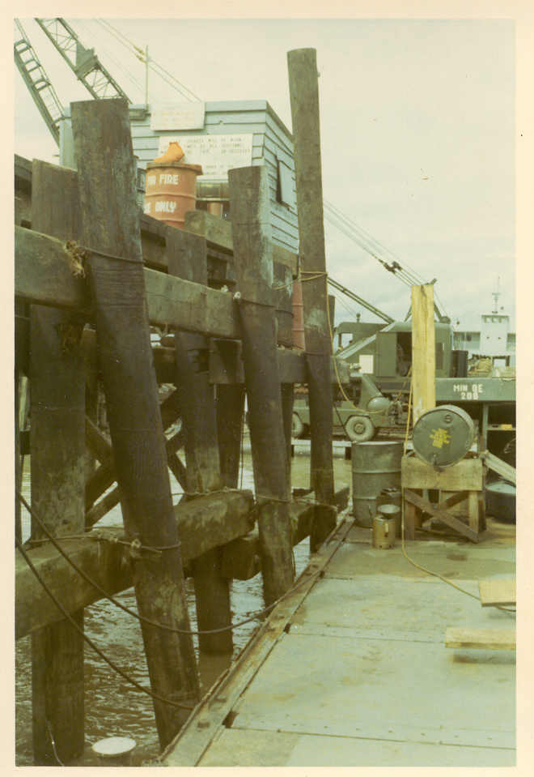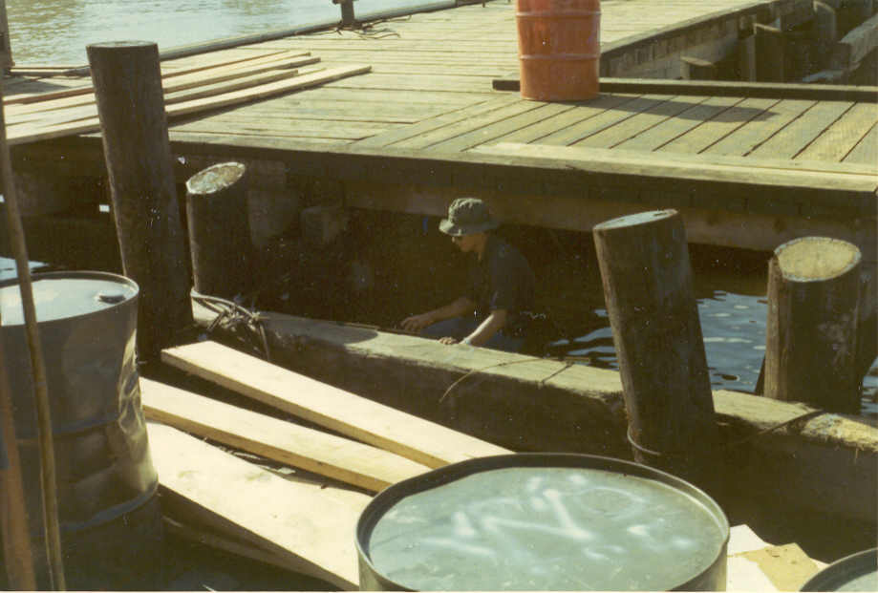
Low—low tide High tide. What a difference!

Cat Lai Scenes (cont.)

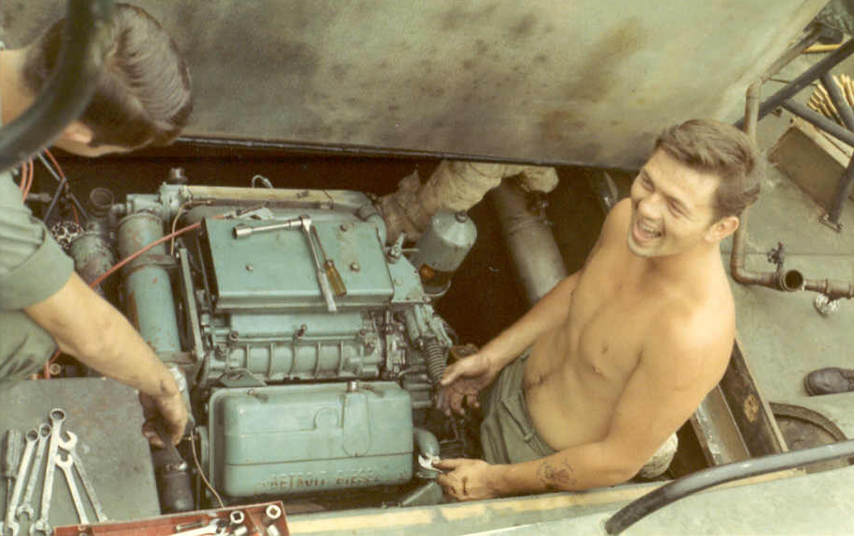
It didn’t seem this funny at the time (Who are these guys?)

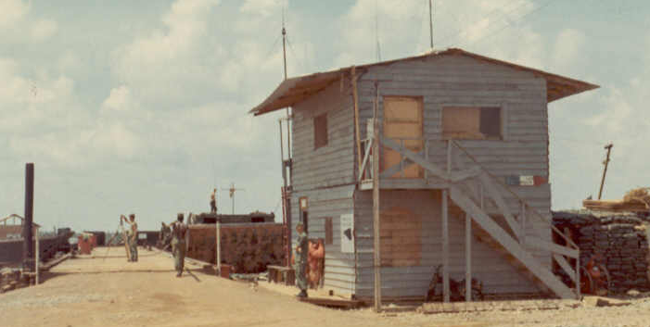

1099th Communications Shack
Pier leading to PBR Barge

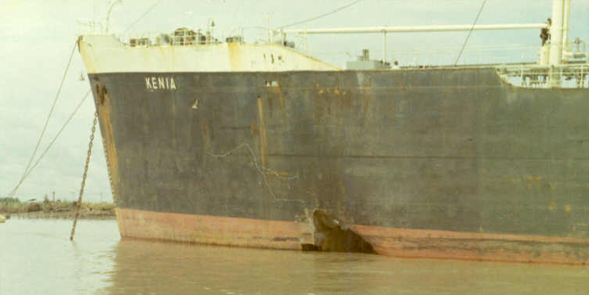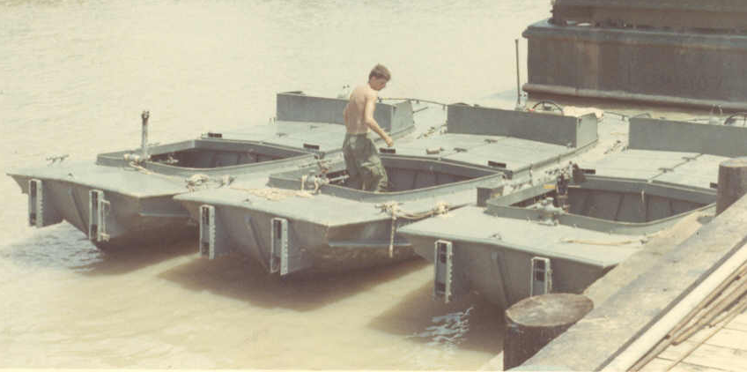
Oops! Engineer boats for pontoon bridges

More Friends

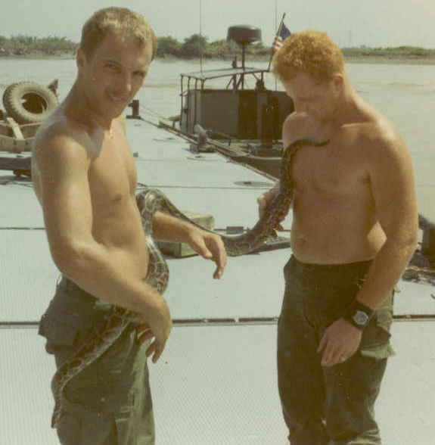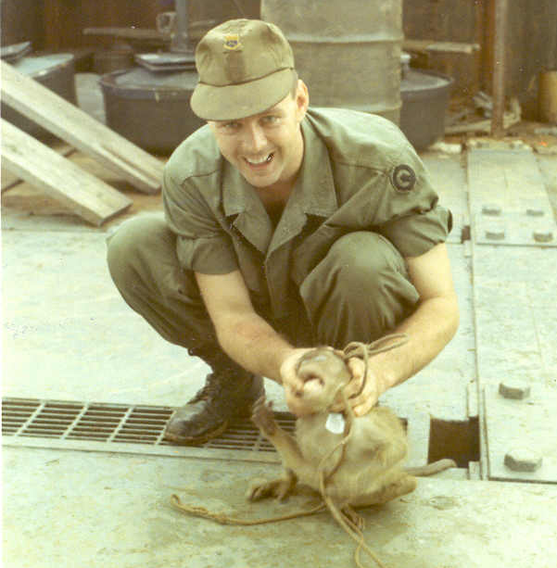
Snake & Friends (Newport) March about to get bit by Jo--Jo

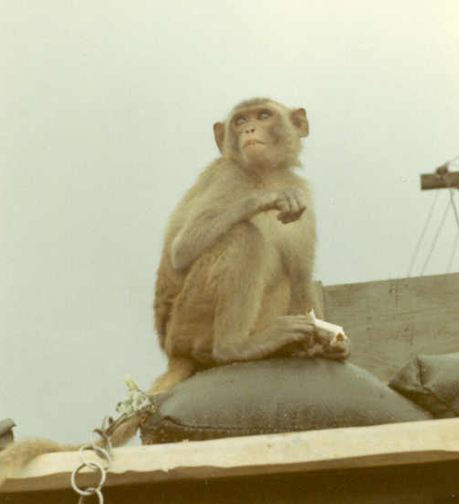
Note Jo—Jo’s tether: Grenade pin rings!

